Title: Ty Undone

14 Nov 2025

# Ben & Ty v3k Alpha

by Seth Poole and Kai D. Waddell



© 2025 by Writers Sub-Vert Stories

All rights reserved. No part of this publication may be reproduced, distributed, or transmitted in any form or by any means, including photocopying, recording, or other electronic or mechanical methods, without the prior written permission of the publisher, except in the case of brief quotations used in reviews or critical articles.

This is a work of fiction.

Names, characters, places, and incidents are products of the author’s imagination or are used fictitiously. Any resemblance to actual persons, living or dead, or actual events is purely coincidental.

Alpha Draft Disclaimer

This is an unfinished work of collaborative fiction — an early draft still in development. It may contain themes, behaviors, or events that some readers could find disturbing or uncomfortable. Please use your best judgment. If that’s not your thing, feel free to give it a pass.

That said, we genuinely appreciate any feedback you’re willing to share. If you’d like to pass it along to friends, we’re happy for that too — just please let us know first.

These excerpts are works in progress.

Thank you for reading,

## Act 1

### Chapter 1: zz1 - Ty rise and shine, good morning, Bella Vista

Tuesday, May 27. The Bella Adobes Garden Center on the outskirts of Tucson.

The dim segmented red numbers on an old Sony alarm clock read 5:47. A sticker on the clock's button said it was “MFGD 1979”. In Japan. The clock was about forty years old. Ty was twenty. Stack two of them, and that’s the clock. Anyway, why set the alarm? The damn rooster, Mike, was outside crowing up the morning. Ty liked to plot Mike’s early demise.

*Ring around the Rosie,*

*Pocket full of posies.*

*Rooster, Rooster, step on a landmine.*

*Way up in the sky,*

*This Fourth of July,*

*He’ll ride a bottle rocket high,*

*And then litter the sky!*

*Rooster ashes, ashes, gonna rain down.*

\[img room\]

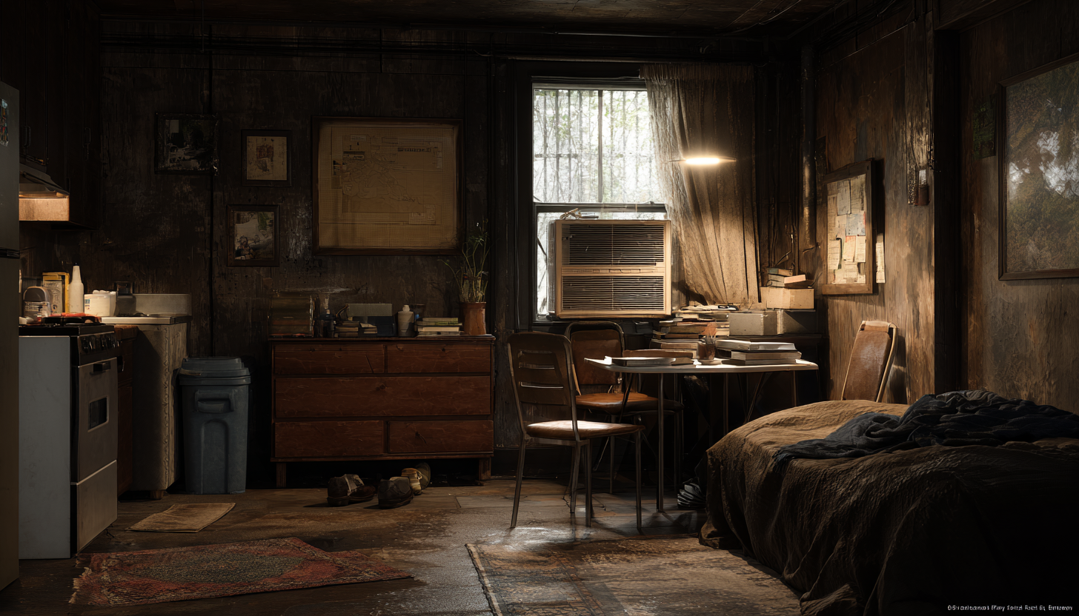

He exhaled, threw off his covers, and sat up. His single room in the back of the main nursery storage building had a smell of damp soil and peat moss. And also, the weird, sweet odor of the Fabuloso purple cleaner he used on the floor. An ancient noisy window AC kept the room tolerable. It didn’t seem right to complain. Isabella wasn't charging him rent.

Time for his morning chill shower. He grabbed a towel and headed to the nursery bathroom at the front of the building. There was no lock on the door and so he'd grabbed a concrete block so that he could jam it shut while he was inside. There was no hot water, so he had learned to soap up and rinse quickly. It woke him up, that's for sure.

Outside, the sky was still gray, with clouds obscuring the sunrise. Back in his room, he pulled on overalls and an old t-shirt, then laced his boots. He headed out to the main yard. The thermometer by the greenhouse door read 79°. It would be 97° by noon.

Isabella was already there. She arrived at daybreak. She moved along the aisles with the hose, watering rows of yucca, yarrow, and holyhock. The back aisles held the desert succulents: salvia, agave, and potted cacti.

She saw him and waved him over.

"Good morning, boss." Ty gave a big smile.

"Hi, you doing okay? Did you eat something?"

"Yes, the last two of those tamales you gave me."

"Okay, Rose is making more today, so I'll have another batch tomorrow. You like the chorizo, right?"

"Yes, ma'am." She paused and looked around the yard and then along the side fence. "Can you keep going with the re-potting?"

"Sure, will do."

"And then put them up front—maybe then they'll sell."

"Got it."

"Where's your water bottle? Make sure you drink a lot today, okay? I don't want anybody getting heat stroke."

\[img isabella\]

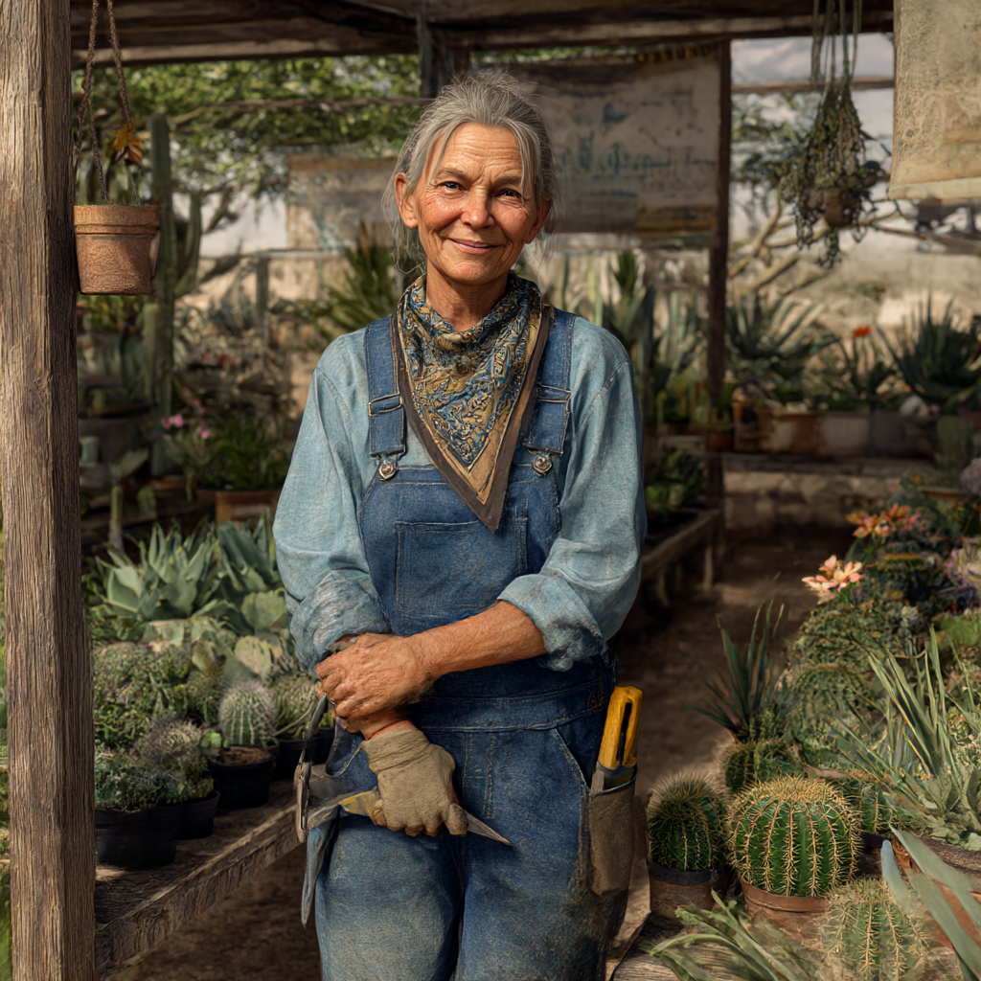

They'd open in a few minutes, but for now, he headed over to the potting workbench. He enjoyed this task, and Isabella said he was good at it.

He had been here at this nursery for a bit more than a month. He signed on as a short-term seasonal worker for three months to help out for the summer. So far, he liked it. It was a good setup for him. Rent included, friendly people, and Isabella was always brought him homemade meals. Her wife, Rose, was a great cook.

Ty had arrived in Tucson a few weeks ago, on May 14th. He stepped off the bus into the Arizona heat. After 27 hours on a bus from Madison, Wisconsin. He was slowly getting used to the climate.

The morning shower brought a nice chilly shock.

Isabella had asked him if he needed it fixed. “No, it's fine. It's my morning wakeup jolt. And then that coffee you make, that's the second one.”

She laughed at this. She always laughed at what he said—really, just all the time. He told her last week that she should pay him for all the free entertainment he provides.

“Free?” she smiled back, pretending to scold him while leafing through some invoices. “I am paying you, remember? And it's not for your work. You hardly get anything done. Face it, you're just our diversity hire.”

"I knew it. Diversity as in I'm the only staff that doesn't sleep with women? Or because of my awesome body?" He tried to do a body builder pose.

"Yeah, no, none of the above." She didn't even bother to look up from her notes.

### Chapter 2: zz2 "Doubtful, sweetheart."

Tuesday, May 27.

Ty walked out the door and into the open main garden yard. It was going to be another oven day.

He needed some more price tags for the pots, so he headed over to the office. Isabella was working on setting up another display and she saw he was by the counter.

"Sweetheart, can you grab me the pliers?"

"Sure." He grabbed them and jogged over to her. "You know, I'm not used to such terms of endearment… 'sweetheart', etc. You're spoiling me. What will I do at the next place? Where my nickname will go back to "hey, kid" or "Yo! meathead!" I don't know, how about if you and Rose just adopt me?"

"Sounds good! You could replace the damn cat. He's so old that he doesn't make it to the litter box anymore. You are house-trained, right?"

"Barely."

"No matter, you could be our miracle love child." She began humming the Supremes' "Love Child".

"I would like that." Ty nodded.

A few minutes before seven, a beat-up Sentra pulled up at the front gate and honked. Ty's co-worker Maya jumped out from the passenger side. Maya was in her late twenties. She'd worked for the nursery for three years and helped out with everything. And she was the expert with the cacti, agave, and palo verde trees.

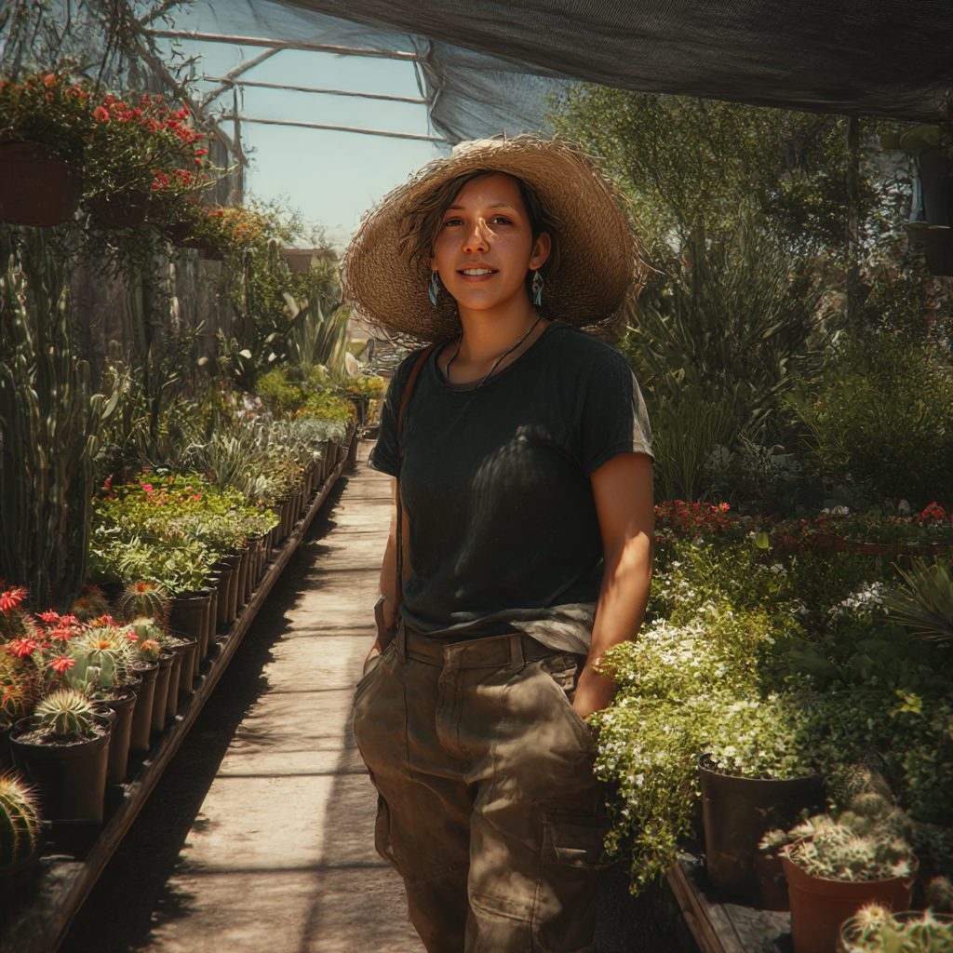

\[img Maya\]

By the second week, she and Ty were razzing each other nonstop.

She smiled as she got to the counter. "Good morning, people."

Isabella smiled and nodded.

"Good morning. Oh, wait, where's your Starbucks?"

"The line was too long."

Ty tried for his drama look and turned to Isabella. "Boss, I'm really worried. I think we're in trouble. You know, Maya without her dirty chai is like… I don't know… Charlie without his crack?"

Isabella smirked. "Not to worry, I'll go make another pot. Double strength."

Ty continued with his performance. "I don't know. I think we should send her back to rehab."

Maya gave him her vulture stare. "Starting early today, are we? When are you going to fix the labels on all the yucca pots?" She turned to Isabella. "Did you see this? He put the wrong stickers on them."

"I asked you if those were the right ones!"

"They were the right stickers for the Glorioso's. Whatever. I'll fix them." She started turning on the point-of-sale and the register. "So how was your shower this morning? Extra chilly, I hope."

"Brisk."

"You're weird. Isabella will fix the heater if you ask her."

"I like it."

"See? Weird."

Isabella looked up. "Aww, he's a good weird."

"Perfect something, yeah."

Maya had logged on to their old desktop and was checking messages and emails.

"Ready?" Isabella asked, looking at the big clock.

"Yep, yes, all systems up. And yeah, I do need coffee." Maya looked at Ty. "Go open the gate, runt."

His eyes narrowed. "Yes, fine, I know a word that rhymes with… oh, never mind." He walked. to the big, suspended front gate and slid it open, the old metal rollers screeched. He propped it open with a cinder block and then got busy with some transplants.

A bit later, a Range Rover pulled up. An annoyed woman got out, mid-40's, gesturing, in the middle of some unpleasant conversation of some sort. Sunglasses perched on her head. Designer jeans and a white linen shirt, she stood right in the entrance.

Ty was by the racks in the front. She ended the call and looked around.

"Can you help me, please?"

"Good morning, sure." He walked over, wiping the dirt off his hands.

She paused and looked at him. Then looked at his name tag. Just a capital 'T'. Her brow furrowed.

"I need three of those agaves. The blue ones. And four bags of that garden soil. Can you load them in the back?"

"Sure."

"You'll need to put some plastic down first. I don't want dirt in my car."

"I'm sorry, we don't have plastic. We can loan you a tarp. Just bring it back."

"Oh no, that's too much trouble."

"We can have it delivered then."

"What's the charge?"

"I'll have to ask."

"I would think you'd know."

Isabella was walking over. She'd already sized up the situation. "We have some cardboard crates, recycled. We can place the pots in them."

The woman considered this. "Fine. But be careful. I don't want dirt everywhere."

Ty maneuvered the large plants into the boxes and set them in the back of the SUV.

"Be careful not to get any dirt on there!" The woman pointed at the interior trim.

"Yes, will do." Ty had learned to stay neutral.

He finished loading the soil bags. The woman inspected everything, then nodded.

Maya was helping another customer who'd just arrived. An older Mexican woman in a faded denim shirt and sun hat. They greeted each other in rapid Spanish. Isabella joined them after the Range Rover was gone.

"What days was Miguel working this week?" ty asked Isabella. Miguel was a part-time landscaper who came to drive the bobcat to move pallets and the big pots.

"I told him just to come on Thursday and Friday. We have that delivery to the event venue," Isabella replied. "And by then the mulch will be here, so be sure to eat your Wheaties."

Ty held up his skinny arms in a bicep flex. "Sure, check these guns. I'm gonna be macho buff, right?"

"Doubtful, sweetheart." Isabella didn't even look up.

At the main counter, under the large awning, the radio was on. A Spanish station played mariachi ranchero music, exuberant DJs, and jarring commercials.

Ty could focus on the news and pick up some of it. He had taken a year of Spanish in school.

"I'm going to try and learn." Ty pointed at the radio when Isabella returned.

"Good idea. You'll pick it up fast. Your brain’s still young. Take the old laptop and watch some YouTube videos. But keep it plugged in—the battery's shot."

"Aren't you worried he'll watch porn?" Maya suggested.

"Maya, stop!" Isabella laughed.

Ty flashed her the finger.

"Yeah, that's what I thought." Maya nodded.

* * *

Before lunchtime, Ty was finishing up with the re-potting. A beat-up gray Tacoma pulled up by the gate. A trim man, somewhat Asian, with long dark hair, dressed in nice jeans and a fitted shirt. He looked corporate but cool. He was heading into the yard and he spotted Ty nearby.

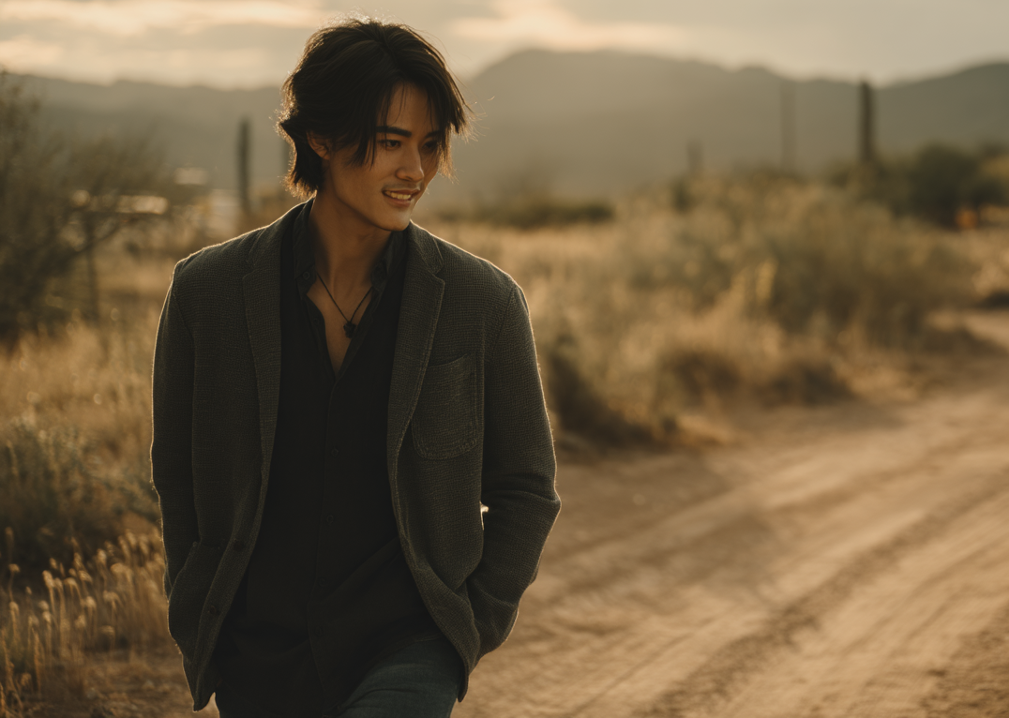

\[img ben first appearance\]

“Hi, excuse me,” the man said, his voice warm but uncertain. “I’m looking for some plants—actually, a bunch—for planters on a balcony.”

“Of course.” Ty pulled off his gloves and walked over. He thought, *I must look like a dumb hick farm boy.* *Covered in dirt and fertilizer, sweat-soaked and smelly, wearing a ridiculous sombrero-sized straw hat.*

He aimed for a decent tone. “What kind of plants are you thinking about? You said for a balcony?”

“I’m not sure, but it needs to be something I can’t kill… like I always do—in a week.” The man smiled.

Ty played along. “Oh, one of *those* people. Floral Abandonment. Planticide. The grim reaper with a gangrene thumb.”

“Right.” The man was a bit startled. He looked at Ty and then laughed. “Wow, impressive. So yes, something like that. Maybe I should just go artificial?”

“On a balcony here, exposed to the sun’s UV, artificial plants won't last six months. We'll help you keep your plants alive. We can send you weekly reminders, and you can tell us if they would be friendly or not." Ty smiled.

The guy followed Ty as they went through the aisles, and Ty gave a quick description of the types of plants suitable for large planter boxes.

Ben continued to explain. "I work some days from home. I'd like to have something nice on the balcony that I can look at during the long Zoom calls. Right now, there's nothing."

Ty pointed around the yard. "Sure, I'm not an expert, but those native plants would be good, hardy, low maintenance."

"Okay, I guess first things first, though. I need to come up with the sizes of the planters." Ben's voice held genuine interest. This was not what Ty was used to.

"Okay, right. That's the starting point, but you can begin thinking about the plantings. Will you want flowering types, succulents, even cacti or aloe. I've only been here a month, but the owner, Isabella, is the expert." Ty stopped in front of some flowering shrubs. "These chuparosa would be nice too. They bloom almost year-round." He turned and raised his finger. "If you water them regularly."

"Chuparosa." Ben repeated the word carefully. "That's beautiful. What does it mean?"

"Hummingbird flower."

Ben had reached out and touched one of the red tubular blooms. "Gorgeous. Okay then, I will start to figure things out. And I should get a hold of Isabella, then?"

"Yes."

"Okay, then, thank you."

"You're welcome." Ty nodded to him.

* * *

At lunchtime, the three of them sat under the wide awning of the main building. Big overhead fans churned the thick, warm air. Isabella perched on a stool; phone pressed to her ear as she must have been on hold with a supplier. Maya sat on another stool, munching on chips. She turned to Ty. "What did that guy want? The one in the old pickup?"

"He's going to contact Isabella. He wants some planters for his balcony."

"You both were pretty chatty."

"Shut up."

Maya smirked and crunched another chip while pointing to the box of donuts she brought that morning. There was one left, a jelly-filled. "Hey, eat that last donut. So that I don't."

Ty checked the box. He looked in the box and said, "Nope, not eating that one."

"Why not?"

"Those are the ones with buttholes."

"What!?"

Ty held up the donut and pointed to the indentation where the jelly injection was inserted.

"Are you from fucking Mars?" Maya managed to appear astounded.

Isabella was done with her call and hung up the phone, she'd overheard enough to know they were at it again. "What now, you two?"

Maya's eyes were wide. "Did you know that donuts have buttholes?"

"Really?" Isabella calmly responded.

"Not all of them!" Ty protested. "The ones with no holes!"

"Show her." Maya ordered.

He held up the donut again with its butthole revealed.

Isabella looked, looked at Maya then back at Ty. She dropped her head.

"And Ty's boyfriend stopped by. He's got a name now. Ben."

“You have a death wish.” Ty pointed, then turned to Isabella. "Boss, if I wanted to bury a body, what's a good spot? Maybe up by Marana?"

"Sure." Isabella was back at work with the invoices.

"Uh huh. I'm not afraid of you, you skinny shit. I outweigh you by twenty pounds." Maya pulled up her sleeve on her right arm and set her elbow on the counter. "C'mon, let's arm wrestle. Mano a Mano. By the way, have you ever had your hormone levels tested?"

Ty prepared unload but Isabella jumped in, laughing. "Both of you, stop! And Maya, that's mean. Hormones? That's harassment!" She seemed serious. "Ty, please don't report us to the state."

"He wouldn't do that." For a moment, Maya looked actually worried. "Right?"

"I haven't decided," Ty said, as if mulling it over. He turned to Maya. "Bring me a double hummer latte every morning for the next two weeks, then I'll think about it." He grabbed his gloves and headed back to the potting table.

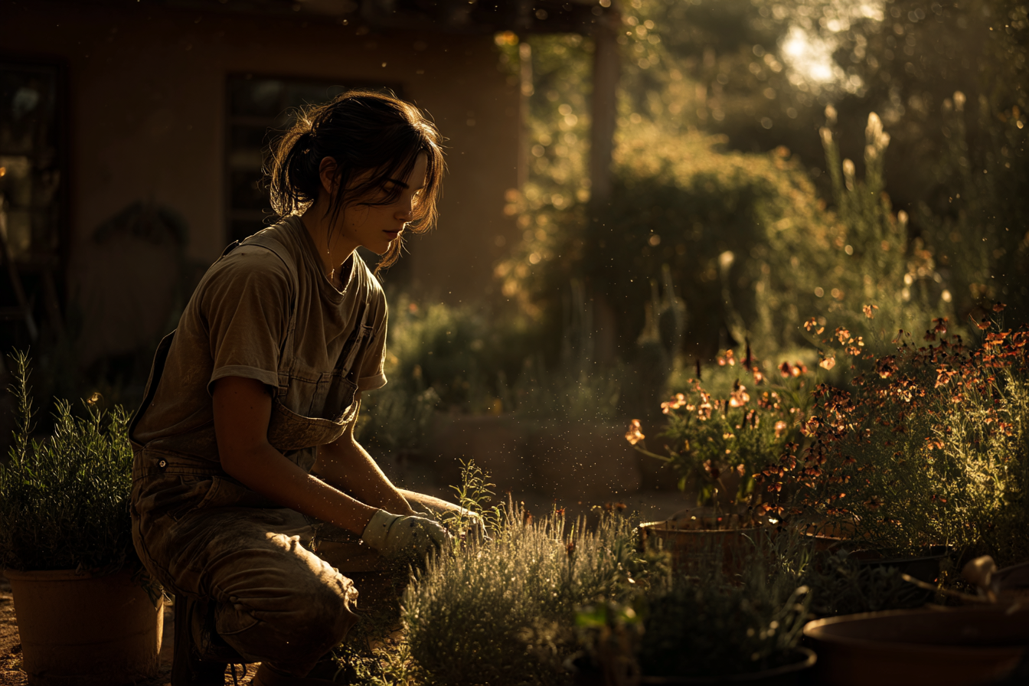

\[img Ty planting \]

Midafternoon, a couple came in looking for potted desert roses. Ty helped them pick some out and then got them loaded into their car.

It was a good week. They had good business, happy customers, and even a break in the weather. And Ty felt like he'd found a decent routine. After they closed, he'd get a shower, rest a bit, and then figure out dinner. Some nights, he'd warm up some food that Rose made for him. Other nights, he headed over to Ana's, a small Mexican diner, about three blocks away. Ty would sit in the back booth, get some dinner, and watch the TV. Auntie Ana always gave him extra rice and beans—and she didn't charge him for the fountain drinks. On slow nights, she would come and sit, and they'd chat. By 9 PM, he'd head back to his room.

\[img POSSIBLE SCENE BEAT ADD dialogue with Ana with some of her mantra\]

### Chapter 3

Wednesday, May 28.

The next morning, the alarm went off at 6 a.m. Ty woke up in the middle of a seriously eff'ed-up dream.

*He was traveling alone, unsure how or why he’d ended up in a beat-up gas station convenience store. It was dark, maybe 2 a.m., and the place was empty except for a wild-eyed older man behind the counter.*

*Ty looked down and he was wearing only a worn tiny white towel around his waist, holding it tight to keep it from falling. No shoes, no shirt. Like he had just stepped out of a shower in a lockerroom. The floor in the store was sticky and black. He didn't know what was happening, only that he had to eat something. Nothing else mattered. He grabbed a burrito from a cooler and took it to the counter. The old man was leering at him, yelling "No shirt, no service! Get out!"*

Then he woke up. Nice dream. No shower this morning. He was not feeling energetic, or even in the mood.

It was three years since he'd left home. Left Syracuse. Seventeen, a junior in high school. It was in mid-November and already cold outside. He was at school, done with his 7th period PE class. He always waited outside after the class ended. He waited for the locker room to empty out so he could change clothes without being bothered.

Heading out, someone jumped out behind him and grabbed him in a bear hug and dragged him back into the empty room. Someone big, arms like a gorilla, and breathing heavy. Ty could turn and see who it was—Matt Price, captain of the wrestling team. Was he fucking around here. He was one of Ty's main tormentors. He had a hand clamped over Ty's mouth, and he didn't seem to be just messing around.

"Shut the fuck up, pussy." His sweaty face pressed against Ty’s neck.

Ty squirmed, but the guy was over six feet tall and twice his size. Matt grabbed the handle to the janitor's closet, got it open, and heaved Ty inside. He fell against some supply shelves. The door banged shut, plunging the room into near darkness. A sliver of light from under the door illuminated a crazy anger on Matt's face.

"I've got something for your skinny little ass." He punched Ty in the gut. Ty buckled to his knees. "Stop!" Ty cried. Then a right hook slapped Ty's face.

"You sound just like a little girl. Come here!" He grabbed Ty's hair and pulled his head into his crotch. He tried rubbing Ty's mouth on the bulge in his pants. "You like this?" With his free hand, he lowered the sweats to his knees and looked at himself. "Jesus, I'm hard!"

Ty wriggled, grabbing a shelf, but Matt yanked his hair again. With his free hand, Ty drove his fist into Matt's groin. Then again. Matt cursed and dropped, falling into a stack of boxes.

Ty scrambled for the door and got it open. He ran from the locker room, down the hall to the main gym. He couldn't breathe, tears blurring his vision. A freshman gym class stopped to watch him sprint across the floor. The PE teacher, Mr. Stalls, yelled, "What the hell!"

Ty didn't look back. Matt could catch him in a second, but he wouldn't risk being seen chasing him with his sweatpants down. Ty hit the side door and sprinted around the corner of the building. He took cover behind the long bus garage, waiting, peeking out. Nothing. His backpack and books were still in the locker room. So, what.

He needed to get home. He cut through the woods, taking the side streets. He kept looking over his shoulder. Report it? Why? He’d tried that before, twice, once after Matt and his friends stripped him on the bus when he was fourteen. After that, they chased him down behind the tennis courts and beat him. The dean had suggested Ty had asked for it. These guys, Matt included were the school top jocks. Hell, Matt's parents owned a car dealership. The teachers probably thought Ty wanted to seduce them.

Either way, he was done. He’d already decided.

Matt and his buddies would be waiting for him tomorrow. Maybe they'd even come to the house, but then they'd risk running into his dad—an alcoholic who liked to wave his handgun around. Not to protect Ty, just to feel like a man.

He had made it home. His dad was in the back. Fox News and Rush Limbaugh blasting away. Ty went upstairs to his dark bedroom and packed a gym bag. He took the cash he'd saved, a couple hundred bucks, and his sketchbook. He walked out. The screen door banged behind him. Even though it was almost dark, he took side streets to the main road and caught the city bus downtown to the Greyhound station.

An 8:10 p.m. bus to Cleveland was leaving. He was on it. *Guess I won't be turning in my science project on Monday…*

He texted his friend Kenny, then called. "I'm leaving." Kenny would post the photo of Ty's bruised face and the message on Instagram and then delete Ty's account. He'd be long gone. He didn't tell anyone where we was headed. At least he felt safe. He'd try and be invisible.



That was two years ago. He'd made it out. A few stops between then and now—Cleveland, Chicago, Madison. But with each new stop, it was further away, in time and distance.

### Chapter 4: Zz3 - Ben returns to the Nursery with an offer

Thursday, May 29.

It was the Sony buzzing at 6am. Ty rolled over and shut if off. He must be getting used to Mike's bellowing. He been sleeping through it lately—and no crappy dream this morning. He got his shower and headed out to see Isabella.

Until noon, he was in the back helping Miguel. He was a part-timer now, a 70'ish ex-hippie who had been friends with Isabella since the beginning of time. This morning was driving the old Bobcat tractor, bringing in half a dozen pallets of mulch. Once he dropped them down, Ty would begin unloading the bags.

Next, they loaded a dozen large shrubs, in massive terra cotta clay pots, placing them into the delivery truck. When they had them ready, Miguel and Isabella headed out.

Maya was at the counter, working on the computer and on the phone.

It was hot. He had finished stacking the mulch and needed some water and shade. He headed over to the counter.

The gray Tacoma pulled in. Ty recognized it. The cute guy from Tuesday jumped out. He headed over to where Ty was standing at the checkout counter.

"Hi again,” he said.

“Oh, Hi, welcome back.” Ty going for nonchalance. He gave a quick nod, looking at the guy as he took a swig from his water bottle.

The guy stood there a moment, a bit stiff. “Say, I wanted to ask, kind of out of the blue, I know. Would there be a way that you could build some wood planters? I have specific sizes in mind. Do you do that kind of thing here?"

Ty smiled at him. This guy seemed shy, a bit awkward.

"Yes, I remember you asking about that. Sure. I mentioned it to the owner, Isabella, and she said it was no problem. We have a local carpenter that we use. Isabella's not here right now though. She's out on an appointment." Ty replied.

“That's okay. She seems busy. How about you? Would you be able to help?”

“Not sure." Ty looked at him. "I'll ask her. I'm new here and she'd have to coach me through it."

Ben seemed pleased and nodded. "Okay, I'm not in a rush.”

Ty paused, then gave a shrug. "Sure. Alright. We'll let you know."

“Great, by the way, I’m Ben, Ben Nakamura.” Now he looked at Ty's single-letter name tag.

“Nice to meet you. I’m Ty.”

Ben pointed at his grimy name tag. “I wondered what the T stood for.”

“Oh, the Y fell off again. No wonder that lady asked me if I was Tina or Theresa or Timmy?”

“Oh, really? Like that?”

"Yeah." Ty shrugged. "It's fine. Takes all kinds, right? I'm used to it." Ty looked at him trying to figure him out. He looked down again at his tag and smiled at Ben. "Yep, that's me, missing the ‘Y’."

Ty paused a moment and laughed. "Oh, I never thought of it. Like I am missing the ‘why,’" and he spelled out the letters. "Or a 'why what?' Like ‘why get up in the morning?’ Or wait, wait… maybe Y chromosome?" Ben was looking at him. Ty stuttered now. "Oh, sorry, sorry, I sound like I'm disturbed… or possessed."

Ben grinned. "No, no, you’re fine. That was… funny." Ben looked over the aisles of plants. "If it's okay, I'll just look around. I want to take a closer look at the plants. I am not too familiar with the names."

"Sure, let us know if you have any questions. Take as long as you like."

After ten minutes ben came back over. He smiled a moment, then reached in his pocket. "I like some of these. Can I give you my card? Then call or text me. Is that okay? Then I'll have your number, right? So I can send you, you know, the information on the planters.”

"Sure." Ty nodded and headed over to the front counter and to grab a pen and one of the nursery brochures. He wrote his cell number on the paper and handed it to Ben.

Ty smiled. “Okay, I’ll talk to Isabella and let you know. Nice to meet you."

"Nice meeting you, thanks." Ben turned and headed back to his truck. Ty watched him as Maya came over.

"Business or pleasure?"

Ty turned and looked at her. "Don't start. Business. I only do business."

"That's not what my spidey sense was saying."

"Well, your spidey sense is broke."

An hour later, Isabella was back. "We've got some delivers coming tomorrow." she said.

"Guess who came back looking for Ty." Maya said.

Ty looked her. "He wasn't looking for me."

"That cute guy from Monday?" Isabella responded.

"Jesus, you two! Nosy people." He sat down on the stool.

"That's right. I am your nosy Aunt Maya, looking out for the little one."

"Wonderful." Ty, now with a full eye roll.

"So, what did he want?" Isabella asked.

"He's looking for custom planters for his balcony."

"Wood?"

"Yes."

"Yeah, we can do that. You want to work on it?"

"Sure, if that's okay. I gave him our email, and he said he'd send measurements and samples over today."

Isabella nodded. "Sure, let's see what he's thinking about."

"Can Maya be my assistant? I'd like to boss her around… for a change."

"Fat chance."

That afternoon, his phone buzzed with a text from Ben. He had attached some photos and a pdf with the dimension of the balcony.

Ty walked over to where Isabella was going through invoices.

"Okay, here's what he sent."

Isabella looked at his phone. She zoomed in on the floor plan, then scrolled through the photos. "Wow, nice. Ask him to email these, and we'll sit down tomorrow and go over them."

"Will do."

### Chapter 5: Zz4 - Ty works on Ben’s planter design

Friday, May 30.

First thing, Isabella called him over. "Your guy sent an email. Let's take a look." She had printed off Ben's email with notes and a layout of the balcony.

They sat at the desk behind the front counter.

"Now, let's just get our bearings, okay?" She grabbed a pencil and a pad of graph paper. She made some quick sketches showing drainage holes, gravel layers, soil depth, and placement. "You want the planter to balance with the plant. And then, consider how a particular species will grow. Also, think about its root system too. You don't want the plants battling one another in the soil either."

On the laptop, she pointed at the sample photos Ben had sent. "See how these are clean? That's what he wants. Low profile. Modern. Minimalist."

She handed him the ruler. "You sketch it out. Calculate the volume, right? In cubic feet. And I'll check your math." She teased him. By lunchtime, Ty had a couple of rough drafts.

"Good start," Isabella said. "Work on it somewhere when you can. We'll go over it tomorrow."

That evening, Ty walked to Ana's Diner with his sketchpad tucked under his arm. The heat had finally backed off. The sun hung low over the hills, painting the adobe buildings orange. the place was nearly empty. One young couple sat in the corner booth, heads bent over their phones. Ana stood behind the counter, wiping down the coffee maker.

"Hey, stranger." She grinned. "Where you been? Haven't seen you since… when?"

"Monday, I think." Ty slid onto a stool and set his sketchpad on the counter.

Ana poured him water without asking. "The usual?"

"Yeah."

She called the order back to the cook and leaned on the counter, eyeing the sketchpad. "What's that?"

"Planter designs. For a customer."

"Neat. good for you."

A full platter of Pollo con Mole arrived a few minutes later. Ty ate slowly, sketching between bites. Ana was cleaning up the other tables, humming to the diner playlist.

He ate quickly so she could finish and close up. He walked back between the shadows and the street lights. Evenings were nice. Things cooled off. usually there was a breeze with cicadas buzzing up in the trees. It was all deserted. the nursery was far enough out from the city that there were not many cars at night.

He entered into the main yard through the side gate, crossing the quiet open rows of flowers and plants. Along the tall old fences, floodlights shown. In his room, he threw his sketchpad on the table and drank cold water. The guy was on his mind. Yeah, he was glad to have the project. He had no training or experience, but Ty had shown Isabella his sketchbook when he first came. He was happy she'd decided to let him work on it. And to coach him through

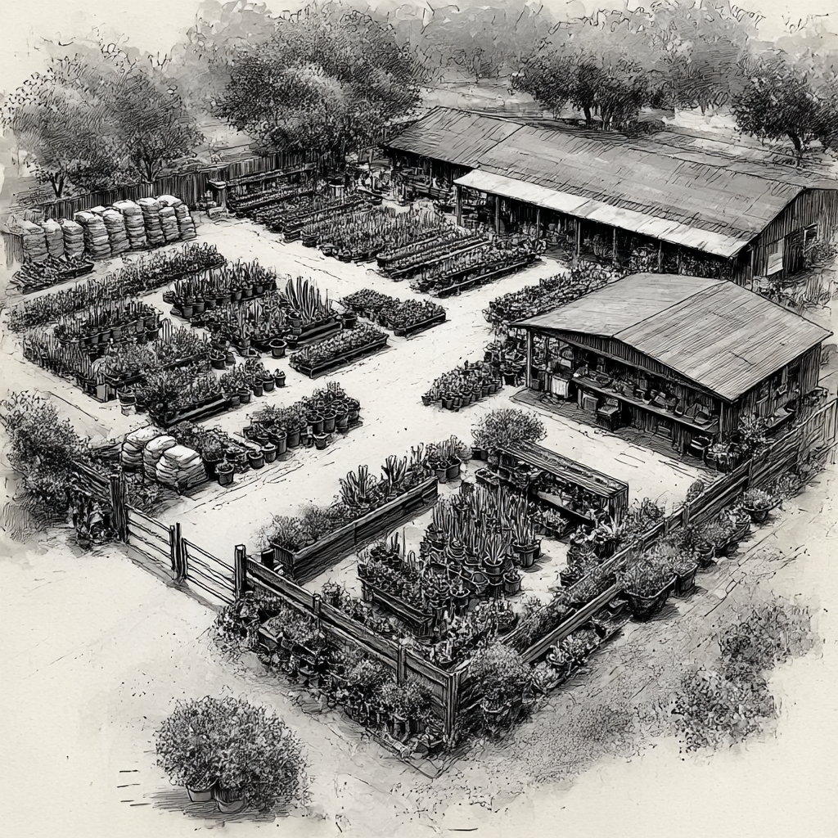

\[img nursery sketch\]

He had a done an imagined sketch of the nursery - she liked it and made a copy of it and pinned it to the wall

The last time Ben had been at the nursery. He had wandered down the aisles of shrub pots and had just stood there staring at one of them. Obviously pondering something but god knows what. Just a way of looking. Whatever that meant. It was like he could sink into contemplation, even on a cheese sandwich.

Not that Ty had seen him looking at a cheese sandwich. Or any sandwich. But then what? Well, maybe at that shrub. *Look at me? Sheesh… There I go again, into an elliptical orbit. Do you know how much space junk there is? All the trash floating around Earth's orbit! And when we send things up there like people in a space station, that thing is constantly having trash slam into it, because everything up there is traveling at a thousand miles a second. Did you know any of that? I just heard it on the radio. It's all exhausting. Well, there my brain goes again.*

*My dad when he was still human, probably I was like five years old, he had a favorite saying when things got to be too much: 'Full count, and Babe Ruth hits one outta here. There it goes, ladies and gentlemen, over the left field wall.'*

*That's me, over the left field wall.*

---

The rest of the week fell into a rhythm. Each morning, after the rounds of watering, Ty would sit with Isabella at the big potting table. She leaned over his sketches, her pencil circling a measurement or tapping on a drainage detail.

Ty felt like the designs and specs were ready. He had put together three options: the measurements, drainage specs, and possible plantings. Isabella gave him the okay to send them out to Ben. A bit later, a text arrived on his phone.

*Ty, these look great. Can we get together and discuss them?*

He hadn't expected that. Why wouldn't he ask his questions, or just decide on which one? Or call Isabella? But fine, he didn't mind.

Ty texted back, *Sure, Monday? It's my day off.*

*Okay. Perfect. Thanks, Ben.*

### Chapter 6: ZZ5 - Monday Meet at Ana’s First time

Monday, June 9.

On Mondays, Ty could sleep in. Sunday nights, he stayed up late, his K-pop playlist cranking on a small Bluetooth speaker, working on his sketches. Usually, he ate dinner at Ana's and was back by 8 p.m.

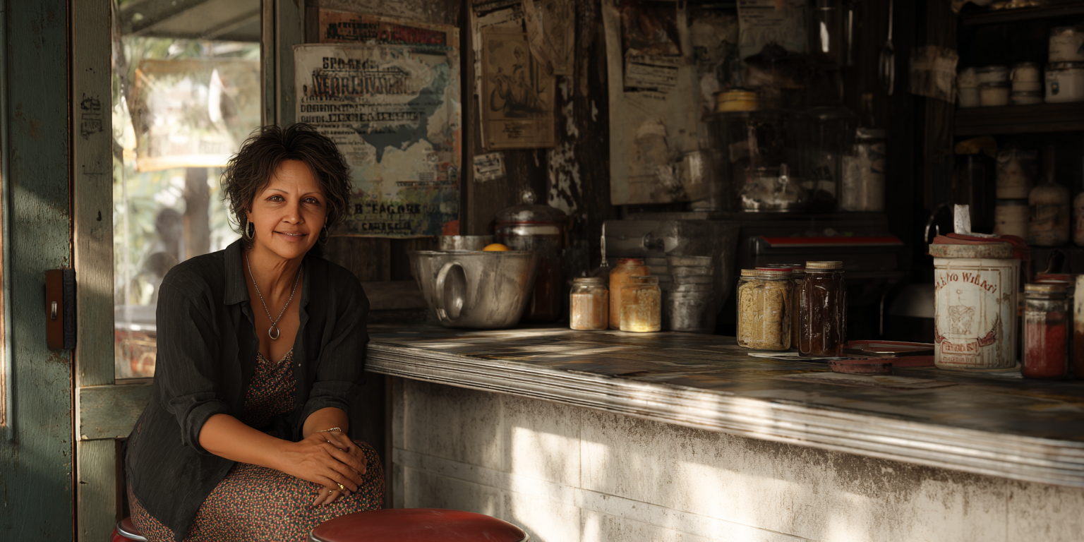

Today would be a "business meeting" with client Ben. He laughed at the idea. Had he ever been in a business meeting?

Ben said he'd be at Ana's at 11. Should Ty put an entry on his calendar? "11 a.m. review proposal with balcony guy."

He preferred calling him "balcony guy" instead of Ben. Something jerked in his gut otherwise. He had one decent pair of jeans and a black t-shirt that was at least clean and not yet beaten.

Ty walked in five minutes early. Ben already sat at the back booth. Ty laughed; that’s where he always sat. Two cups of coffee were on the table. Ben gave a slight wave. Ty slid into the booth across from him.

"Thanks for coming. I got coffee. Is that okay?"

"Perfect. Sorry, have you been waiting long?"

"No, you're on time. Thanks for meeting me—on your day off?"

"It's no problem."

Ben sipped his coffee, then opened his laptop and turned it so they both could see. He scrolled through the drawings Ty had sent him. "I think I like this one." He pointed at a low-profile platform design.

"Good. Yes, that was Isabella's favorite, too. Did you check the measurements and proportions?" Ty asked.

"Yes. And I saw your question about irrigation. I'm not planning on that. I don't want to go to the trouble of installing it, so I will try to be diligent and keep them healthy. Maybe you could write me a schedule?"

"Sure." Ty agreed.

"Yes, I'll stick to it. I plan on turning over a new leaf…" Ben realized his phrasing. "Oh, that's a horrible pun. I apologize."

Ty laughed. "No, no. It's great. Even better if not intended."

That seemed to relax things. Ty found himself looking at Ben as he scrolled through other pictures. He shook himself. *Back to business.*

Ty spoke up. "So what else? If you're set on the design and sizes, next I can contact the woodworker for a quote."

"Yes, that's fine. When will you need a deposit?"

"Check with Isabella for that. I'm just the farmhand."

"So you'll do the plantings?" Ben asked.

"Yep, that'll be me."

"Good." Ben nodded as he closed his laptop. "So I'll let Isabella know."

"Great. Thanks."

Ty gathered the papers and started to get up. Ben spoke up.

"Hey, if you're not busy, can I buy you lunch?"

"You don't have to do that."

"Sure, just offering. I was going to stay and order something."

"Are you sure?"

"Of course."

Ty looked at him. "Well, okay, I guess. Then you won't have to eat alone."

"Exactly. Although I do that all the time."

"Me too."

"Well then, what do you want? The specials looked good. Have you eaten here before?"

"I eat here just about every night."

"Oh, okay." Ben gave a warm laugh. "Then what do you recommend?"

"Pollo con Mole."

"Perfect." Ben nodded again.

"I'll tell her." Ty got up, went to the counter, and gave Ana their order.

When he sat back down, Ben asked, "How long have you worked at the nursery?"

"Just a month," Ty said. He explained further.

"So before that?"

"Well, that's a long story. I've hopscotched around for a while."

"Really? How can that be? You're what? How old?"

"Twenty."

Ben's brow went up. "Really?"

"Yep. Originally from Syracuse, but I left almost three years back. From there, I worked in small garden centers, nurseries, and one time at a wholesale grower. Just seasonal gigs. So I move around."

"You left home at seventeen?"

"Yeah." Ty kept his voice careful. "There were some problems, school, family, all the usual."

Ben nodded. He seemed genuine but didn't press. "Sounds rough."

"Yep. But I'm getting by. No longer on the run." Ty raised his brow to underline the joke. It was a joke, right? Well, sort of. Ty continued, "And Isabella is wonderful. She's my new mom. This is the best place I've been. I hope I can stay. The gig ends in three months, but we already talked about extending it. As long as business is okay. And I'm learning a lot. She's always explaining stuff, and she gets into the science of it. Plants and climate are so different here versus the Midwest. It's really interesting. And of course, I love working with plants."

Ben nodded. "And I wanted to ask you, the sketches, did you do those?"

"Yes."

"They were very good. Where did you learn?"

"I've always drawn stuff. I'd get in trouble in school for drawing instead of paying attention. And I took some art and drafting classes. You know, gay boys gonna be artistic. Anyway, it's my therapy. Keeps me off the heavy meds." Ty hoped Ben took that as a joke.

"Yeah, okay. Sure." Ben smirked. *How does this guy know when I'm joking?* Ben smiled at him. "I wish I was half as mature as you at twenty."

"You're funny. You seem like you've always had it together."

"Really? Well, I'm glad I put up a good front." Ben replied.

Ty thought, *Okay, I managed to deflect. Geez.*

Ana brought their food just then. "Here you go," she said, looking at Ben. Ty spoke up, "Ana, this is Ben. He's a customer at Isabella's."

"Oh, really? Okay." Ty thought she seemed a bit skeptical. "Well, enjoy, boys. Do you need more coffee?"

Ben looked at Ty and then at Ana. "Nope. We're good, thank you."

They dug in. Between bites, Ty asked, "What about you? You mentioned you moved here from Denver."

"Yep, I'm here for a project. At least a year. We have a big client in town, and I need to meet with them regularly. I didn't want to fly back and forth—I hate flying. And I felt like making a change. And so far, I like it here.

"So just you?"

"Like, am I married? Nope, just me. Although I'm thinking about getting a dog." Ben laughed.

They finished. Ben had cleaned his plate. "Want to get going?"

"Yep," Ty replied. "Thanks again."

* * *

The next day, Isabella received an email from Ben, choosing design #2. She told Ty, “Congratulations, your first project."

She had checked with the carpenter and he thought he'd have them ready in three weeks.

Ty had just gotten back home from Ana's when his phone buzzed: a text from Ben.

*Hi Ty, can we meet again sometime this week?*

Ty squinted at the screen. Isabella had just confirmed the order with the fabricator that morning. Was there a problem now? He texted back, *Is there a problem with the order?*

Ben's reply came right back. *No, that’s all good. Just wanted to hang out. Same place, Ana's?*

Hmm. Ty stared at the screen. He didn't want to overthink it. Let's just hang out. He typed back, *Okay.*

### Chapter 7: ZZ7 - 2nd Ana’s Monday - Big Talk

Monday, June 16.

Before 3pm, Ty headed over to Ana's. Ben was waiting out front when Ty walked up.

They walked in, and the place was empty. Ana was probably in the kitchen. Ty called out, "Hola, Ana! It's me and a friend."

Ana called back, "Ty? Hi, honey! Sure, sure, grab a seat."

They sat in the same booth as last time.

"So, what's up?" Ty asked.

"Not much. Thanks for meeting up."

"What did you want to go over? Did you change your mind about the planters? Talk to Isabella about a refund?" Ty joked.

"No, no. Of course not." Ben smiled back.

"So?" Ty looked back at him and waited.

"Was there something else you wanted to cover?" Ty kept his voice professional.

"No, not really. We're good." Ben shifted in his seat. "I like the food. Sorry, did it seem weird?"

"No, no, I just wasn't sure." Ty shrugged. He put his phone down. The screen displayed an old Expressionist painting—a Modigliani portrait.

"I'll try something different." Ty watched Ben study the menu. His hair fell forward a bit over his face and he smoothed it back.

"Do you want a beer?" Ty asked.

"Sure."

Ty got up and went over to grab a couple of bottles from the case.

“So it’s self-service here…" Ben smiled at him.

“Yes, didn't you know? I sub here as the waitress too? Be sure to tip." Ty panicked. *He'd said that with way too much what? Flourish?* "Shit, I mean waiter. I'm a waiter."

Ben laughed, his eyes were bright. "Ty, it's okay."

He knew this was now awkward. "Sorry, that sounded… never mind. I'm usually not so… obvious."

"Ty, no worries." His eyes were still so kind. and happy. "And I'll leave you a good tip."

“Ahem. So, what about you?” Ty, now desperate to change the topic, asked. “Where did you grow up? Go to school? All that stuff? Brothers? Sisters?”

Ben laughed again. "Okay, okay."

do they chat a bit more - so ty could talk about his growing up

"Oh, sorry, you're busy?"

"No, not at all. But there's no need."

"C'mon. Let's have some lunch. You said the food's good. Or sorry, do you have somewhere you need to be?"

"I have nowhere I have to be." Ty laughed.

"Okay then." Ben looked back at the menu.

“So, you said you’ve just been here a month? Where did you come from?”

"Originally, New York. Syracuse. But I'd been moving around for a couple of years, just taking seasonal gigs at nurseries in the Midwest. This was my first time out west."

“Are you going back home to visit?”

“No. Not likely. I’m working here until October and then I’ll find something else. probably keep moving west until i fall in the ocean.”

"How about you? Had you always been in Santa Fe?" Ty asked.

"No, no," Ben said.

Ben noticed the wallpaper on Ty's phone. It cycled through 19th century painters.

"Now it's Matisse?"

Ty glanced down. "Yeah. Good call. *The Snail*."

"Are you a fan?"

Ty laughed. "That sounds funny, 'Are you a fan?' Sort of like asking, are you a fan of Taylor Swift, or deep dish pizza."

Ben smiled. "Geez, okay then. Are you an aficinado of Expressionists?"

"Some. More the Fauves, I guess. They were my mom's favorites—Matisse, Derain, Vlaminck."

"That's pretty specific. I feel like this may be the first time this year that anyone discussed the Fauves in this diner."

"Safe bet. Anyway, my mom had a lot of art books. We'd look through them together. Then Uncle Lou would come over. We'd go to the museum, and I'd listen to them they'd talk for hours."

"Uncle Lou?"

"Well, he wasn't really my uncle. A friend of the family. Or really, of my mom. My dad couldn't stand him."

Ben was curious. "Really, why?"

"He was gay. That would be enough right there. But he and my mom hung out a lot. They had been friends since college."

"How about you? Are you a native?" Ty asked.

“No, no. I grew up in San Diego,” Ben said. “My dad's American-born Japanese, and my mom's from Germany. Well, sort of. My grandparents are in Munich now, but my mom was born here. My dad's an electrical engineer. He works for Rockwell.”

“Never heard of Rockwell.”

“A big defense contractor.”

Ty nodded. "What does your mom do?"

"She's an interior designer. And I'm an only child. You?"

"I have an older sister. She's still back in Syracuse."

Ben's fingers traced the edge of the menu. "I was in Denver for a while after college. Did my masters work in Japan for a year, then came back to the States. Ended up in Denver doing design work for a tech startup."

"What kind of design?"

"Visual. Branding, UI, UX, some illustration. The startup folded last year, so I started with this bigger firm, and we got a big client here in Tucson.

"You like it here?"

"Yeah. It's quieter than Denver. Less... I don't know, showy and urban."

Ana came out from the kitchen, order pad in hand. "What can I get you boys?"

Ben ordered the green chili chicken burrito. Ty got the same.

After Ana left, Ty leaned back. "How old are you?"

"Twenty-nine. By the way, you're not old enough to drink."

"Oops. And I'm a truant." Ty winked.

"Guess you should put that beer back and get back to class."

"Too late." Ty polished off the last of his. "The evidence is gone, and my trail's gone cold."

"We'll check the DNA and bring out the hounds."

Ana hustled out from the kitchen and came up to their booth. "Hi, Ty! Who's this?"

Ty did the introductions. "This is Ben. Ben, this is my Auntie Ana."

Ben nodded and smiled, "Hi there!"

Ana smiled. "Yes, yes, what can I get you boys?"

Ben ordered the green chile chicken burrito, and Ty got the same.

In ten minutes, Ana brought their food out on heavy ceramic plates. Rice, beans, guacamole, and the burritos, big and coverd in green chile and cheese.

After they finished, Ty sat back in the booth. "Can I see some of your work?"

"Sure. I have a website, although it's really current. I'll send you the link later."

"Send it to me now."

"No." Ben teased.

"Fine!" Ty shook his head in mock exasperation.

"Hey, would you like to go to dinner sometime? Just hang out?"

Ty was caught off guard. "Sure, I guess. I don't do anything here other than work and sleep."

"There's a Tex-Mex place, El Rancho Rancho; have you been there?"

"No." Ty paused. "But can I change the name?"

"Of the restaurant? I guess, if it makes you happy."

"Rancho Rauncho."

"Cool. Definitely. I like it." Ben gave a knowing look. "We can pitch them a whole new marketing campaign. The tagline can be 'get rauncho at El Rancho!'"

### Chapter 8: ZZ8 - Dinner at Rancho Rauncho - CTJ

Thursday, 6/19

After work and a quick shower, Ty headed to El Rancho Rauncho. It was a fifteen-minute walk, so he should get there right at 7:30. He turned the corner and saw Ben, standing out in front, on the phone. He looked around and waved when he saw Ty. Ben seemed a bit tense.

"Hey," Ty said as he reached him.

"Hi, sorry." Ben pointed to his phone. "Yeah, I'm sure we can get it fixed. They're just not understanding how the SEO and keywords work. I'll straighten it out tomorrow, okay?" He ended the call and exhaled.

"Sorry about that."

"No worries at all. If you have to make a call, I'm fine. I'll just sit over there. No rush, Ben."

"No, no. They treat everything like an emergency. Let's head inside."

The place wasn't too busy. They took a booth and ordered. Ty was hungry and chose the Bistec Ranchero.

Ben ordered margaritas, and the waitress brought them a minute later.

"They must have them on tap," Ty quipped.

“When do you turn 21?” Ben whispered.

Ty lowered his voice, “Shhh. Not yet. October. And there always watching. You know, they've been after me since that diamond heist in Bel-Air."

Ben played along. "I heard about that. Someone snuck out the necklace in a potted plant. An azalea, I believe."

Ty now raised his voice, "Exactly!"

The waitress dropped off two more margaritas.

Ty continued. "And you, you’re 29. Oh dear, on your next birthday, you'll be… old.”

Ben's eyes narrowed. “Sure. Fine. On your next birthday, you'll get to shave.”

They both sat there a moment. Ty did not want to make eye contact, but he felt Ben looking at him. He grabbed his glass and raised it for a toast. “Yes, and here's to fabled adulthood.” He gulped half of it. "Yum."

“Careful, Godzilla." Ben cautioned. "So will I be invited to your birthday party?”

“There won’t be a party. Nobody's gonna know. Well, maybe Kenny.”

"Kenny?"

“My only friend from school. Back in Syracuse, right? And the only person back home I still talk to. Well, sometimes my mom too, if she’s doing better.”

Ben nodded for a moment. "What about Isabella?"

“Oh yeah, that's true. I've been asking her to adopt me.”

Ben laughed. “Sure, anyway, what's the date? October? I’ll remember.”

“You mean your app will remember?”

“Do not separate the man from the machine.”

Now Ty laughed. "I like that both of us say shit that makes absolutely no sense." He felt warm for a moment and risked a look at Ben. He was calm, comfortable, and just smiling back at him.

The food came out. Big platters of steak, rice, and beans, tortillas, and guacamole.

In 5 minutes, Ty's plate was clean. "Oh, god, that was good." Ty sat back from the table. "I need to loosen my belt." He finished the rest of his drink. "And I haven't had margaritas in a long time."

"Like what, not since the Korean War?"

"That was my grandfather."

"Sure." Ben have him a look. "So, tell me more about Syracuse."

Ty shrugged. "A topic to be over before it even begins. It sucked in the winter. And summers sucked too, for that matter. Along with the weather, not a lot of happy times. Especially once I got older. My father hated his job, and would drink and throw a tantrum every night, slamming doors and yelling about shit. The Communists, or now, the socialists and immigrants and fags. Of course, having one for a son—well, that just made it even better. He kept call me 'trans'. He had no idea what that meant. He watched Fox News until his brain rotted."

"So, where's your mom?"

"She's had a rough time. But we're close, but she goes in and out of long spells of depression, eating disorders. Like the kind where you're unable to function. She stays with my aunt a lot. Probably to avoid being around my dad. As far as my sister, she was already gone when I was growing up. There's a big age difference; we've never been close. she's thirty something and married to yet another rightwing nutjob. I want to move to France."

Ben seemed to be processing all of it. Okay, Ty thought, now was as good a time as any.

"Ben, I have a question."

"Yes?"

"Actually, I just want to kind of, you know, clear something up."

"Okay, sure." Ben replied.

"We're just buddies here. Hanging out, right? A couple of dudes at dinner?"

"Sure, what do you mean?"

"I mean, you know I'm gay, right?"

"Okay, yeah."

"And you're straight?"

"Yes."

"Just straight?"

"Ty, come on."

"Sorry. Okay, never mind. Look, I just don't want to misread things here. I'm having a nice time. I told you; I don't do anything but work and sleep. So, this is great. I just want to make sure, okay?" Ty paused. "By the way, you don't have to buy me dinner."

"Okay." Ben seemed a bit stalled. "But buddies can pay for a meal. I mean, I asked you to go. And it should be my treat. Don't worry about that. Or any of the other stuff."

Ty looked at him. "I'm sorry, I didn't mean to freak you out. I just thought, well, I wanted to make sure, you know, clear things up. I mean, you understand, why I'm asking, right?"

"Yes."

"And?"

Now Ben was quiet and finally said, "I don't know."

Ty's shoulders fell. He was trying to make this easy. "Okay, Ben, to which part of what I said are you saying, 'I don't know.'"

Ben seemed sewn up, then finally, "Ty, sorry. Yes, I understand your question. I understand the confusion. I'm not trying to be cryptic. So yes. We're just hanging out."

"Okay, done. Topic done. Except, can I ask you one more thing? You seem pretty comfortable being around… well, you know, a Molly."

"A Molly? Where the hell did you get that word?"

"It's a real word. Look it up."

Ben grabbed his phone and did a search. He laughed and read it out loud: *"18th Century Gay Subculture 18th century London was home to a flourishing gay subculture with Molly Houses at the centre of the social scene. 'Molly' was a slur used for effeminate, homosexual men."*

Ben shook his head. "Oh my god, that's hysterical."

That seemed to relax things a bit.

Ben continued, "So yes, I am quite accustomed to being around all kinds of 'different' people." Ben started to list off. "In college? Fine Arts major; half the department was gay. Summers? I worked the bar at a trendy restaurant—the whole wait staff was maricón. Growing up, hanging in my mom's antique shop? You do the math." Ben smiled back.

Ty stepped in. "Got it. Okay then. So, you were surrounded."

Ben shrugged, "I'll tell you something. Most of my 'real' friends, the nicest people I've known, they are of that persuasion."

Ty flashed a small smile and put his napkin on the table. "Okay, are we done here?"

"Sure."

### Chapter 9: ZZ9 - Invitation to art gallery opening

Wednesday, June 25.

The weekend went by, and Ty didn't hear from Ben. That's fine, he thought. Maybe in fact Ty's "is something going on here?" question had in fact bothered him. Fine. I’d rather get the any weirdness out of the way. No matter whether that was him or Ben, or both of them.

Ob‐La‐Di, Ob‐La‐Da.

Yesterday had been a long sweaty day. They had gotten a delivery of nearly a hundred potted sage and cypress plants. He, Miguel and Maya were unloading and moving them all morning. He checked his phone after lunch. A missed call from Ben, then he saw a text, *Give me a call.*

Ty headed over to get some water.

Maya looked over at him. "Isabella says there's another delivery coming."

"Great." Ty replied.

He pressed the callback on his phone and Ben picked up.

“Hi. How're ya doing?”

“Wilting, like a burning bush. But without Moses. Why the hell would anyone live here?”

“It's fine as long as you have AC."

"Thanks, jerk." Ty teased.

"Me? Maybe."

"No, definitely."

Ty could see Ben face. Smiling with each comeback. Then Ben asked, "Hey, quick question, I have a friend who's having a gallery opening this Friday.”

“Gallery?”

“Art gallery, noob. Would you like to go?”

Ty rubbed his grimy forehead. “I don’t know… I think I'd feel weird. And I have nothing to wear. My wardrobe screams 'displaced sharecropper'.”

Ben laughed. “Come on. Just wear jeans and a T-shirt. It's fine."

“Clean ones?”

"Preferably."

"Are you sure?"

Maya was watching him from across the counter.

Ben persisted. "Yes, come on. You'll have a good time."

"Okay, deal, it's a date." The words came out before Ty's brain had caught up. "No, no, I mean, not a date… a plan. Yes."

Ben was laughing. "Yeah, yeah, whatever, See you then."

He hung up and Maya was still watching.

"What!?" he yelled at her.

"A date, huh? Oh wait," She started to mimic him. "Tee hee, not a date. Sorry!" She was having a good time.

Ty narrowed his eyes. "Do you want to go for a drive in the desert? Just let me get some rope and a shovel."

"Sounds like Workplace Threats and Intimidation to me. I'm calling HR."

### Chapter 10: ZZ10 Ty at the Art Opening

Friday, June 27

Ty was standing by the main gate when Ben pulled up. He gave a small wave. Ben's hand lifted to wave, then it faltered mid-air. Like he wasn't expecting what he saw. Or rather, who he saw.

Ty had dressed up. He thought, *why not? Let's doll ourselves up for the evening*. It was not something he'd done in a long time. And even then, only in his bedroom at home or over at Kenny's.

But during the week after work, he'd gone into town to some thrift stores and found an "outfit"—a linen suit, quite fluid, in retro look that fit him well. Under that he had a sheer black shirt that he left open.

Okay, it was all a bit over the top, yes, andro-femme. Also he’d borrowed makeup from Maya. And put his hair up/ It was longer now so he could pull it back in a loose bun, although strands were already escaping.

He jumped in. "Hey! Thanks for the lift!" He smiled, putting on the seatbelt. Ben wasn't saying anything, just looking at him.

"What?"

"You said you didn't have anything to wear. You look like you're stepping out in Malibu."

Ty laughed. "I don't know about Malibu. This is what I could find in Tucson."

Ben was still looking at him. "Wow."

"Is that a good wow, or… something else?"

"I just wasn't expecting you…” Ben nearly stuttered. “… to dress up like this."

"So it's too much?" Ty now concerned. "I’ll go and change. I can throw on jeans and a t-shirt."

"No, no. It's fine. Let's go."

They reached downtown and Ben parked on the street. They walked past trendy boutiques and knick knack decor shops. Ty could see the gallery up ahead; brightly lit, some people were milling around just in front of the entrance. It was a large converted loft building. Large glass windows extended across the front. As they walked in, Ty heard light jazz playing just over the conversations. The walls of the main room were a flat pure white with the art work displayed in a clean lines. There were large abstract landscapes, using stencils and patched shapes mixed with horizons and distance. They felt expansive. Textured motion.

The crowd scattered across the polished concrete floor in clusters. Older couples in tailored linen stood in groups, looking polite. Some hipsters, and a group of younger people, some trans-ish, asymmetrical haircuts, gender bending and friendly.

Ben spotted a familiar face, his coworker and his wife, and walked over. Ty followed.

"Jesse, Meiko, hey, how are you guys?" Ben shook hands with each of them. Jesse was in his forties and seemed friendly, down to earth.

"Excellent." Jesse smiled back. Jesse's wife smiled warmly, though her expression was somewhere between polite and puzzled by Ty.

Just then, a man in a studded vest and shimmery gray slacks, cut loose through the leg and high at the waist, came over and gave Ben a side cheek kiss.

"Look who's arrived! Ben, Ben! How have you been?"

Ben laughed at Charles' exuberant arrival. "Hi, Charles, wonderful. Though work's not much fun right now. Congratulations on your opening. It's a nice turnout." Ben looked over the room.

"Yes, we're pleased. And Blake's already sold a piece." He noticed Ty standing behind Ben. "And who's this?"

Ben moved out of the way. "This is Ty. A new friend. He works at the nursery where I'm getting my planters."

Charles turned and looked at Ty, his brow raised. "Really? So Ty… it's nice to meet you." Charles extended his hand and Ty shook it. "Um, Ben, can I be honest here? Your friend is gorgeous."

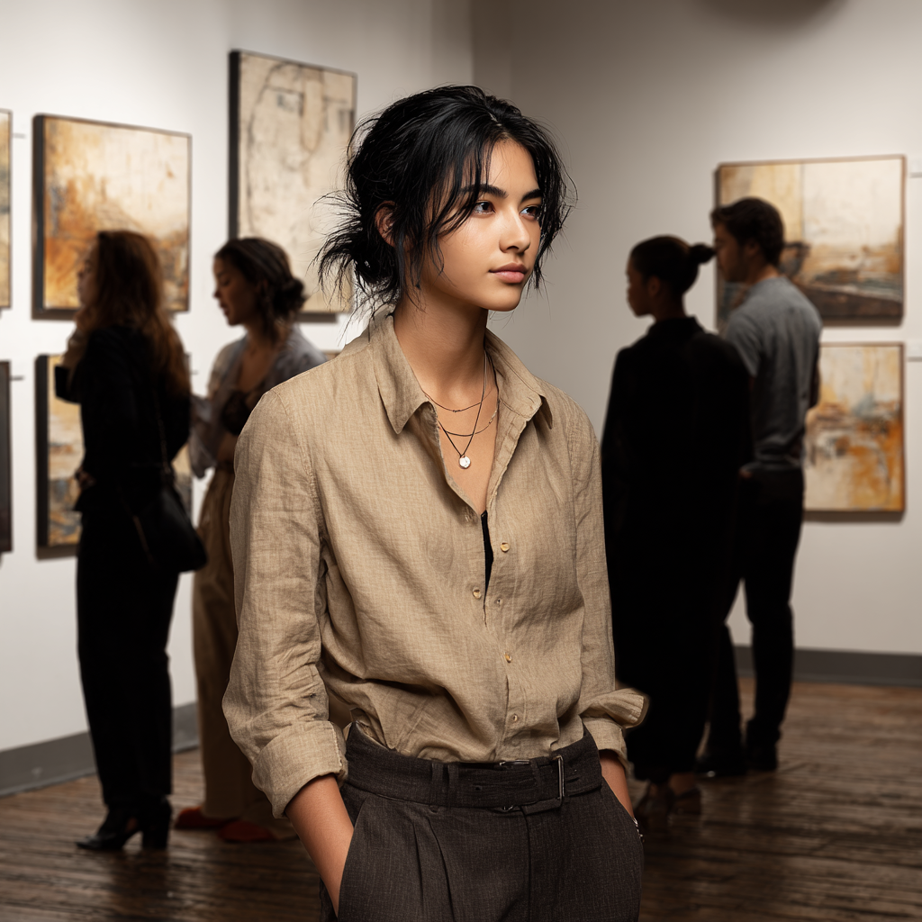

Ty blushed and lowered his face.

Ben saw Ty react. "Charles, don't embarrass the poor guy."

Ty recovered. "It's fine." He said, looking at the main wall. "So, these are your paintings?"

"Yes, what do you think? Do you like them?"

"Very much." Ty said quietly.

Ben spoke up. "Ty actually knows something — he's a fan of the Impressionists?"

"Aren't we all? Well, we must chat later then. Excuse me, I need to schmooze. Ta-ta!"

They stayed chatting with Jesse and Meiko. Then Ben and Jesse got into some ranting about work stuff. Ty wandered off to a corner where there were some smaller paintings.

---

---

Ty came back over, and Ben handed him the glass.

"Thanks." Ty surveyd the room. "So, what's a handsome straight dude like you doing, hanging around all these artsy queer folk?" Ty asked, starting again with the mischief.

Ben's grimaced back. "C'mon."

"Well?"

"What? I gotta be hanging out at Hooters, watching football, and ogling tits? Speaking of which, you'd be a lousy wingman."

"Thanks. But I think you dodged the question." Ty fired back.

"Knock it off."

"Sorry, I can't help it."

"Like 'sorry, not sorry,' right?" Ben fired back.

"Pretty much." Ty looked at him over the top of his glass as he sipped. "Seriously, thanks for bringing me. Quite a show. I feel like I've landed in Never-Never Land.

A bit later, Ty was standing in front of one of the large canvases when Charles again stopped by. “So now that you’ve taken a long look, what do you think?”

“I like them. Especially the smaller ones on that wall. They feel almost Cubist, and then you add on the outlines of plants and terrain. It draws me in. And the colors too."

Charles crooked his head. "Cubist? You know Cubism? Remarkable. Well, yes, I wish I'd see a review in the paper that was half as perceptive."

“So how do you know Ben?”

“I work at a nursery out near the foothills, and Ben is having us make planters for his balcony.”

"Isabella's place?"

Ty was surprised. "Yes, you know her?"

"Of course, she's a doll, and Tucson's a small world, especially if we're talking lesbians and queers." Charles paused a moment. “So, Ty, can I pry?”

Ty shrugged. “I guess.”

“Are you dating Ben?”

Ty's reaction was too quick. “What!? No, no. Just hanging out. He's a nice guy. And he’s straight anyway, right?”

“Well, that's what I'd assumed, but when you two walked in tonight… well, honey, that was *not* the vibe.”

“No, no. No way. He’s a friend. I mean, I don't know—I think he hangs out with me because he feels sorry for me. I don’t know anyone here.”

* * *

By 9:30, the opening crowd had lessened. Ty was back over at the small paintings when Ben came up.

"You had enough? Ready to go?"

"Yes, time for Cinderella to change back into a pumpkin."

Ben did a double-take and then caught on. "Oh, nice, so then, what? I'm the evil stepmother? And anyway, you totally mangled it—the coach turned into a pumpkin."

"Well, Cinderella wasn't a ladyboy."

"What! Who's a ladyboy? And how do you know what a ladyboy is?"

"How do *you* know what a ladyboy is? Have you been holding back?"

"What do you mean? You make no sense." Ben looked flustered but amused. "Come on, let's go. I want to say goodbye to Charles first."

Once outside, they headed back toward the truck. Ben asked, "Are you hungry? There are some late-night food trucks over by the park."

"Hey, Ben. My turn to buy."

"No, no way." Ben's response was firm.

"Wow, excuse me, Mr. MBA."

"That's not what I am, Cinderella."

They reached a large city park, and along one of the main walks, there was a line of about half a dozen food trucks. The place was popular. They got a couple of massive burritos from a Tex-Mex truck.

"Yum, this is tasty, I like food here."

He looked over at Ben. Ben felt him watching and looked back.

"What?" Ben asked.

“I know we've talked about this already. Maybe it's been put to bed. Oh, that's a bad metaphor." He wiped his mouth. "But you see, there's this room and I'm in it, and you're there, or maybe you're not…" Ty looked off, away at the darkness among the park trees.

"What are you talking about now, Ty?" Ben's brows creased.

Ty then continued, "And there's this big elephant in this room, it's an Indian elephant, but it's still big, right? And this is your room, and I can't figure out if I should stay or find a way out. And some weird old guy, a painter, he's painting the floor and painting us into a corner, and then I see there's an escape hatch, or a jet pack—so maybe the best thing for me is to just strap that thing and blast off."

Ben looked at him. "Nothing you just said made any sense. Are you smoking something? Peyote? Or maybe two bottles of Mescal? What in the hell are you talking about?"

"Charles asked if we're dating."

"Sure, of course he did." Ben was annoyed. "That's Charles. He can make a soap opera out of a bag of carrots."

"Carrots can be jealous, have affairs, regrets… suffer breakdowns."

"Ty, seriously, you're..." Ben sounded tired.

"Okay, sorry, sorry. But you're ducking, too. And I'm asking because…" Ty turned to him, "Because I can't read you."

"Huh? Ty, I feel like we've covered this."

"Okay, Sure. I understand. I promise. This'll be the last time." Ty paused. "It's just… this feels like a date."

"I get that," Ben said quietly.

"Ben, you didn't answer the question."

"Yeah. I know."

Ty waited. "Okay, never mind. So clearly this is a 'Me' problem. I keep trying to contort this into something it's not." Ty stared off now at the street. "Ah, yes, this is Ben, a man of few words. That's fine. So, let's flip this. What would you guess is my attitude towards you?"

"No idea."

"Bullshit. Total, utter, crapping cow shit from hell. Fuck you." Ty's voice had raised and was frustrated. "Okay, I'm done there. I have a full day tomorrow bagging manure. I'll see you later." He stood up and began to walk off.

Ben got up. "Ty, wait, I'll give you a ride."

"No, no thanks."

"On, c'mon. It's like ten miles."

"It's fine. Cinderella can find her own way home."

"What the… Okay, okay, Ty, I'm sorry. I'm not trying to play games. Hell, I don't know. But anyway, let me give you a ride."

"Yeah. Okay. That's fine. Let's go."

* * *

There wasn't much traffic on the way back. And Ty didn't want to talk.

The pickup stopped at the main gate. "Ty. Just a minute. I don't have the answer to your question. I mean, I understand it, of course. So, I guess the answer is: yes, it was a date."

Ben looked out past the headlights. "But then I ask myself, what does that mean? I mean, what is this? Do you like me… and if you do, what then? Could it work? I mean, I've never… you know. Would you be happy? What's the right thing here? I don't know…"

Ty sat for a moment and raised his hand like a traffic cop. "Shhh. Okay, got it. That's enough. You just gave me an answer. The rest of that was Ben Brain Seepage."

Ty turned to him. His eyes bright. "I got it."

With that, Ty moved over and kissed him on the cheek and started to get out. "Goodnight."

Ben froze. Kind of like he'd been unplugged.

When Ben didn't reply, Ty stopped getting out and turned back to look. Ben looked a bit stunned. Ty laughed, "Are you okay?"

Ben turned to him. He leaned over and reached for Ty's arm and pulled him closer. Ben kissed him. Not on the cheek. Not a peck. A kiss. Full on.

Ty gasped then he took a breath. Ben was so close. They kissed again.

Ty pulled away just a bit. The look on Ben's face left Ty's chest tight. Now his voice was husky. “I told you, I already had an answer. No need to run the meter." He kissed Ben a final time and raised a hand to Ben's cheek. "Oh man…" Ty whispered. "Gotta go!" And he was out of the truck and heading to the gate.

* * *

Back in his room, Ty sat on the edge of the bed before changing into a big tshirt and boxers. *I need to sleep, but what the hell just happened?*

He'd gone along with this. This 'hanging out with Ben'. A nice and interesting and smart guy. But a bit too good looking for Ty to maintain his distance. He could handle it. Just hang out. It'll be fine. No risk of things getting weird.

*But now what? Can I just explode in a billion fragments? Disappear…"*

His phone chirped. Ben.

*Can we talk. Tomorrow?*

Ty typed back. *Yes. After work tomorrow. Good night.*

### Chapter 11: ZZ11 - Day After the Gallery

Saturday, June 28.

The next day, Ty woke up exhausted. Saturdays were busy. A lot many customers so the day flew by. Ty thought he would strangle Maya if she didn’t stop asking him about the opening.

At lunchtime, his phone chirped.

*Can I come by around 7?*

Ty punched back. *Yes.*

That evening, Ty got a text from Ben that he was parked out front. Ty threw on a shirt and walked out. Ben stood there, leaning against his truck.

"Hey." Ben spoke first.

"Hi. You wanted to talk?" Ty pointed to a wooden bench by the fence. “We can sit over there until the bugs find us.”

Ben had two bottles of iced tea and handed Ty one.

“Thanks.”

They sat down and Ty took a swig. After a pause, he spoke. “So, you kissed a guy last night.”

“Yes."

"First time?"

"Ty, stop it."

“Sorry, I talk a lot of shit when I’m nervous.”

“You're nervous?”

“Yeah, Ben, I'm fucking nervous. I have no idea what's going on. And you're so fucking clueless that you probably don't know how I feel. I'm assuming you're going to tell me that you're really sorry. That last night was a BIG mistake. 'Gee, Ty. I don't know what happened. I mean, you are cute, kinda like a girl… I just got carried away…. yada, yada, bullshit, bullshit. I don't care. This has been fun. Up to the point where you started to drive me fucking nuts. Then not so much."

Ty exhaled and shifted on the bench. "If by any chance, we stay friends, or continue to hang out, or whatever, I would like to get permission—here and now, officially, formally—that I can punch the shit out of you when you say stupid shit like… ‘Gee, Ty, why are you nervous!’” Ty felt himself now on the verge of losing it. He turned his face away and muttered silently, “Fuck, fuck, fuck.”

“Ty, stop.”

He turned and faced forward, wiping his face on his sleeve. “I'm good, Ben. Look, forget it.” He took a heavy breath and rolled his shoulder. "Are we good here? Can we call it a night?"

Ben was quiet, but firmly he said, “No.”

"No?" Ty turned and stared at him. "What? We're not good? Then what?"

Ben again didn't say anything. He was looking down at his hands, then he raised his head, facing forward, and whispered. "No, I don't know."

Ty's face tightened. "So, you gave me permission to punch you, right?"

"Sure." Ben was deflated.

They sat for another minute. Finally, Ben spoke. "Ty, it wasn't a mistake. But I'm not sure of anything else."

Ty stared at him. "God, sometimes I think you were a clam in a previous life."

He slapped his legs. "Ben, it's simple. What do you want? What are we doing? I want to stop now, before this goes any further, okay?" Ty scooted again on the bench. "I'm sure you haven't thought this through. Dump me, don't dump me. But let's stop this." Ty exhaled. "Stay friends? Well, not likely, but either way, fine. You know what's not fine? Not telling me what you're thinking." Ty got up to leave. "I'm going in. I'm exhausted. I didn't sleep last night."

"Neither did I."

Ty now swung around, expression hot. "Oh, that's great. You say shit like that and again, what the FUCK am I supposed to think?" He took a breath. "Okay, then, we both need sleep. And we're out here feeding the mosquitoes."

Ben stayed still. "Ty, I get it. You're right. About everything. I don't know. I don't have anything figured out. But I do know that you're the last person I want to hurt."

"Ben, that's a lot different than wanting to… you know."

"Yeah." Ben gave a bitter laugh. "God, you're something."

Ty held up his hands. "Ben, this is going nowhere. and I'm exhausted. Let's do this. Let's take a break. Call it done. You think about it. Or don't."

"Ty…" Ben reached for Ty's hand, but Ty jerked it away.

"Ben, I'm deciding. A break. Okay? Good night." He headed to the gate.

### Chapter 12: ZZ12 - Ben shows up, surprise: let’s go out

Thursday, July 3.

Maya, Isabella, and Ty were sitting around the front counter. Maya was just finishing up her lunch. There was one customer wandering around the flowering pots aisle.

Ty was going through some notes when Ben's truck pulled up. "What the hell. What's this about?" he said.

"Uh oh," Maya nodded.

"Shut up. Let me see what he wants."

Before Ben got out, Ty walked to the side of the truck.

"The planters aren't ready yet."

Ben just looked at him. "I know."

"So, what's up?"

"Nothing, I mean, not really. How are you?" Ben got out. He seemed taller.

"I'm fine." Ty gave a short nod.

"Can we talk?"

"Yes, Ben, of course. Can we keep it short?"

"Yes, it’s binary."

"What does that mean?"

"I want to see you."

Ty again, a quick laugh. "See me like… through a telescope, from a distance? Through the scope of a rifle? Or see me as in…? what? I charge extra for lingerie. Let me get you my OnlyFans account."

"Jesus." Ben rolled his eyes. "I knew you'd make this easy."

"Okay, Ben, sorry. What's going on?"

"Yes. I want to try. Going out. Dating."

"Really?" Ty stood looking at him. "And what about me? Should I change my mind?"

"That's not up to me."

Ty pondered this. "Okay. But I have some conditions, a proposal really. Because I see a thousand ways that this will not work. And honestly, I don't need that." He folded his arms and rocked a bit. "So, let's put ourselves on probation. A trial period. We take it slow. Deal?"

"As you wish."

"For real?"

"Yes, Ty."

"Okay." Ty stepped closer and held out his hand to shake.

Ben gave his wry smile and shook Ty's hand. "So, how about tomorrow night? There's fireworks downtown."

"But only in the sky."

"Geez, nobody else can… you're brutal. Yes, only in the sky, Ty." Ben sighed again.

"Okay, see you then." Ty gave a nod.

Ty headed back to the counter. Maya was ready, "Well, well, well. I think I can guess what that was about. Just by the clouds you're floating on. Just get kicked in the head by a donkey? You should go lie down." Maya said

Ty couldn't suppress his smile. "Shut up. Mind your own beeswax."

Maya turned to Isabella. "We should have filmed the next season of The Gay Bachelorette right here."

"Is that a real show?" Ty looked at her.

"No, honey, but if it were, you'd be in the Farmboy Picker Edition."

Ty's eyes narrowed. "Too bad the wood chipper's not here. We could reenact that scene from Fargo."

Isabella was the unwitting audience. "Oh my god, stop it, you two," Isabella moaned then smiled to them.

### Chapter 13: ZZ13 - first date - 4th of July Fireworks then Dinner

Friday, July 4.

Ty decided not to get dressed up. Just wear longs sleeves and sweats. Best to cover up to avoid the hordes of mosquitoes that seem to single him out. His mom used to say it was because he was sweet. Yeah, right.

And he and Ben had discussed things again on the phone. They'd keep it cool, as agreed. He put his hair up under a baseball cap and checked himself in the mirror. "Hell, almost a dude!"

He waited out front, and Ben rolled up right on time.

"Hey there!" he jumped in.

"Hi. You look nice."

"Aw shucks, Mister. Really? I'm wearing my groovy '70's tube socks. Ya wanna see?" Ty batted his eyes, suddenly sorry that he'd not done his lashes. "What time's the finale?"

"You mean the fireworks?"

"Touché, douche. Yes, Ben." Ty smirked.

"No idea. I've been tied up. Kind of a crazy day in the office."

"Sorry to hear, so what's up there?"

Ben filled him in on the latest problems—with the project and the client, the company president, who seemed to like to change his mind like he changes his aftershave. Ty was starting to get a idea of all the bullshit Ben had to put up with at work.

"So, I might have to go back to Denver. We're going to try and come up with a way to turn this around, and I need to be there in person."

"That's funny. You move here to be face to face with the client, but then you have to go back there to what? huddle with your boss?"

"Exactly, you got it. Contradictions abound. I'd rather be at my drafting table."

"You still sit at a drafting table?"

"No, sorry, just being nostalgic. Yeah, it's all CAD-CAM now. Hell, even that's out-dated. I'll be replaced by a robot pretty soon anyway, and then you can teach me how to bag fertilizer."

"And grow worms. Yeah, gotta figure that my job's safe."

"You think the robots will need gardens?" Ben was trying to play along.

"Of course, they need somewhere to cover up all the graves when it's time to bury us."

"You can be pretty dark, you know."

"Nah. Really? This is me on a good day." Ty rolled down the window.

They reached the main city park in fifteen minutes. It was crowded, but they found parking. They walked until they found a place to sit. Ben had brought a blanket and soft drinks. They found a place to set out the blanket, along the edge, a line of trees towards the back of the large open lawn. They sat and watched the people, then the show started, the rockets and the bangs. Then the finale.

"Whoa, that was cool." Ty said. "I haven't seen fireworks since forever."

A voice away from them called out, "Bentley! Darling!" It was Charles and his friend Dean. They headed over. Ben and Ty stood up.

"Hi there!" They exchanged hugs.

"Fancy meeting you here."

"Well, yes."

"Nice to see you two again. Together," Charles intoned.

Ben replied, "Stop it. Ty told me you asked if we were dating."

"Yes, and so what's this? A nice little cozy picnic over here all by yourselves?"

"Ty, darling, how are you?"

"I'm good, Charles. How are you?"

"Fantastic Fabulous!" Charles spun a bit to usher in his friend. "Did you meet Dean? Ben, you've met him before, right? He couldn't make it to the show."

Ben looked up. Someone walking along the path was waving to him. Oh shit. It was his co-worker Bob. A nice guy but super straight and always talking about going to church. Ben waved back and started to walk over to say Hi.

"I'll be right back," he said to Ty and Charles.

He walked over to Bob, who was with a woman that Ben assumed was his wife. He'd never talked to Bob outside of the office. They exchanged pleasantries. He noticed Bob looking over at Charles and Ty, and he was pretty sure he could see the wheels turning in Bob's Baptist head. I mean, you can't look at Charles for more than two seconds and not know he's queer. Ben figured that Bob was also quite confused about Ty, who, even though he was in sweatpants and a ball cap, still looked right in the middle between a guy and a chick.

When Ben returned, Ty asked, "Who was that?"

"A guy from work."

"Was he surprised to see you here?"

"Probably."

"And us?"

"Likely."

"Uh huh." Ty nodded.

They stayed chatting. Ty had the urge to put his arm through Ben's. You know, stand there like a couple listening to The Charles Show—rants and gossip and all that. Then Ty just decided, "Fuck it," and he slipped his arm under Ben's as he pulled in closer.

Ben stiffened for a moment, no doubt surprised but then relaxed and brought his other hand up to touch Ty's arm. Okay, wow. Encouraged, Ty now wanted a kiss, but no, no, no. That would be too much. He was content with this. Feeling Ben's contact. Imagining the warmth of him. That was enough.

*Hell, it was miles sky high more than enough.*

Charles of course was tuned in. He had watched Ty's move and smiled mid-rant. He gave a brief little nod and wink.

The four of them chatted for another ten minutes, although it was mostly Charles talking gossip, clients, and exasperating art world things. The show had been a success. His paintings had sold well.

Around the park's open field, the crowd had thinned out, and Charles and Dean decided to head out. As they gathered up the blanket and things, Ben turned to Ty.

"You hungry?"

"Maybe?"

"Ever had sushi?"

"No."

"Why not?"

"How would I eat sushi? I grew up on meatloaf and hot pockets."

"So… this is your chance."

"I feel weird with you taking me out like this."

"Ty, it's a date. I asked you out. You should try it."

The sushi place was four blocks over—a small storefront, maybe eight tables, packed with people. The hostess told them it would be twenty minutes, but a table opened up in five.

Ty sat across from Ben and picked up the menu. "I have no idea what any of this is."

"Trust me?"

"Ha! You better than that." Ty teased back.

Ben ordered a variety platter and some dumplings. The waiter brought green tea and small dishes of a pale green paste.

"That's wasabi. Japanese horseradish. Start with a tiny bit."

Ty dabbed some on his finger and tasted it. Heat shot straight to his sinuses, and his eyes watered.

"Told you."

"Whoa, baby. Nice! I love it."

"Really?"

"Yeah." Ben showed him to mix it with some soy sauce.

The platter arrived—colorful rows of fish and rice, neat and perfect. Ben showed him how to use the chopsticks. Ty picked up a piece of salmon nigiri, and it slipped, dropping into the soy sauce dish with a splash that managed to reach the front of his T-shirt.

"Oops! Shit, sorry." He made a motion to try and wipe it but then just shrugged. "Forget it."

He tried again, and this time got a better hold of it. He dipped it and managed to get it to his mouth. He began to taste and chew. His eyes expanded.

"Well?"

"That's good! God, yum! What's that one?"

"Himachi, means yellow tail, I think, that's my favorite—and that one is tuna. try them." Ben joined in.

Ty tried everything. The wasabi cleared his head. He finished his tea and Ben poured him more.

The platter was empty. All the sushi had disappeared.

"That was great, Ben. Thank you. My first raw experience."

Ty asked Ben. "You never told me about your love life. Your hot girlfriends, one night stands, sex parties."

"Yeah, right." Ben set down his chopsticks. "Not much to tell. I never dated in high school. I liked girls, but I was too scared to talk to them. Too shy."

Ben picked up his tea cup, looked at it, set it back down.

"In college, I had a few sort-of girlfriends. Some dates, sometimes more, but things always petered out." Again, he caught his own pun. "Sorry." Then continued, "Anyway, for sure, they seemed to lose interest, or they sensed I was, or I don't know. I was into other things. Artist friends, I worked in restaurants. The first girl I slept with broke up with me as soon as the semester finished. I guess I was just a course she was taking, a prerequisite."

Ty stayed quiet.

"Yeah." Ben kept going. "My one serious relationship ended three years ago. Not with a bang but a whimper. Rebecca. She was a designer too. We met through friends when I came back from Japan."

He paused while the waitress took away their plates.

"We dated for exactly two years. I could tell she wanted to get engaged. But again, there was that sense of losing interest. And our conversations were becoming like work meetings and she was the project manager—going through action items and status updates."

Ben moved his finger on the placemat.

"The vibe being, time for us to get married. You have a career. I have a career. Her parents wanted grandkids. They'd give us money for a house. She was already pushing me to work on getting promoted and go into management."

"Sounds romantic." Ty kept his voice flat.

"Yeah, exactly. So I got home one Friday, and she gave me an ultimatum. But that was unnecessary. Redundant. We agreed to break it off. We weren't living together so it wasn't messy."

Ben was quiet a moment and then looked at Ty with a slight shrug. "My mom said to me me last year, that I'm too much of a people pleaser. That's not the same as being kind or caring. It's more about not realizing when people are pretending to be nice, but really, they're using you. Manipulating. Controlling."

"Wow, cool thought. You got a smart mom." Ty nodded.

"I do." Ben leaned back. "After Rebecca, after a while, I realized I needed to stop going along with things like that. At work, with family, friends, anywhere. Then I got really busy at work."

He looked up at Ty. "I've always done what's expected of me. And I'm always the one who gets the short end of the stick. I'm gonna be thirty. Seems like a good time for a change."

Ty watched him across the table. "Okay. Time for a change…" Ty put down his tea. "How big of a change?"

### Chapter 14: ZZ14 - second date - low key Monday Daytime Date

Monday, July 7.

Ben parked at the nursery just before 6 p.m. Ty locked up. They walked the four blocks to Ana's together. The heat had broken. Evening air drifted through cottonwoods along the sidewalk.

They ordered burritos and ceviche. The dinner crowd thinned out fast on Monday. By seven, the place was nearly empty except for a couple in a back booth.

Ana emerged from behind the counter, wiping her hands on her apron. She slid into the booth next to Ty, putting an arm over his shoulders.

"So you two are an item, I hear," Ana quipped.

Ty's fork stopped halfway to his mouth. He turned to her, his eyes narrowed.

"From who?"

"I don't reveal my sources."

"Well, I can guess. Send her a message from me, 'Beware the wrath of Ty.'"

"Will do." Ana nodded.

Ben watched, warm and happy. He leaned back in the booth. And Ty looked at him. He looked better, after some food and distraction. Ty looked across at him and he nodded and stayed quiet.

Ana looked between them. "You two look good."

Ty felt his face warm. "That's a jinx. And anyway, we've been on one actual date."

"Sure. Sorry, I'm not buying that." She smiled at them both.

\[ FEEDBACK from mist

Chapter 15 (The Breakup Call): This is the weakest chapter in terms of pacing. Ty’s outburst ("I don’t think you’ve thought this through") comes out of nowhere. Build up to it:

Have Ben cancel a call earlier that day (work emergency), so Ty’s already on edge.

Ty could spiral while repotting plants—literally uprooting things as his anxiety grows.

The call should feel like the last straw, not the first volley.

\]

* * *

Ben left Wednesday morning for Denver. He thought he'd be back by the weekend, but Friday came and went. Then Monday. They were talking every night on the phone. Ty was feeling happy with things. He'd ask Ben about his mom and dad, about growing up. He started to ask about his exes, but then decided it was not the right time—or maybe it would never be. Did he need to know?

Some nights it was only a text., showing up around ten PM.

*Still dealing with this mess. Sorry.*

*Client changed their mind again. Starting over.*

But Ben sounded worn down, his voice flat in a way Ty hadn't heard before.

"How bad is it?" Ty asked one night, lying on his bed with the fan blowing hot air across the room.

"Bad enough that I'm questioning why I took this on in the first place."

"Can you walk away?"

"That's the nuclear option, and there'd be a lot of collateral damage." Ben went quiet for a moment. "I'll figure it out."

"I'm sorry," Ty whispered back to him.

"No, I'm sorry. I shouldn't be laying this on you. I guess I'm just catastro… what's the stupid word? Seeing everything as a catastrophe. Anyway, sorry about this. I know where I'd rather be." His voice trailed off, but tugged on Ty as it went down.

After a moment, Ty's quiet voice, "Yeah. Let's not go there. I'm missing you,"

There was a pause and then Ben spoke, "Ty, I miss you too."

Ty had a sudden ache. *Geez, this guy….*

But he recovered and spoke up, trying to get the emotion out of his voice. "Get some rest, okay? I gotta go."

* * *

Tuesday, July 15.

That morning, Ben had texted him that his flight would arrive around noon and then he'd head to the office for meetings. He should be able to meet up later.

Ben's truck pulled into the nursery parking lot just around seven, and Ty was sitting waiting. Ben got out.

"You're back."

"I'm back." Ben gave a wry, weary smile, and they hugged. "Client crisis averted. For the moment."

"You look like hell."

"Thanks. That's the look what I was going for."

Ty grinned. "So, we just grab something quick at Ana's?"

"Sure."

They walked three blocks to the diner. The evening air felt cooler. Ben rolled his shoulders and stretched his neck.

Ana waved when they walked in.

"Where you been?"

"Denver."

"He's been slaying evil client dragons," Ty offered.

"I see." Ana nodded. "So what can I get you two? We're doing Irish for a special today: brisket and cabbage."

"Yum, that sounds good." Ben put down the menu.

"Sure, me too." Ty smiled at her.

Ana headed to the kitchen.

"It's nice to see you," Ben said.

"You already said that."

"I did?"

"Now I don't remember." Ty smiled back. "So, the client thing worked out?"

"Sort of. We probably salvaged the job, but I had to redo three weeks of work in five days."

In no time, Ana brought their food. Big helpings. They ate without talking. Ben looked ready to fall asleep in his plate.

They paid and made it back to his truck.

"Ben, go home and crash. I should probably drive *you* home."

"Yeah, sorry. Not much of a date, huh?"

"It's fine. Perfect, really."

### Chapter 15: ZZ15 - The Dark Night - The Big Bust

Thursday, July 17.

Two days later, on Thursday, just before midnight, Ty woke from a nightmare. It was the kind he hated, set on a reeking old wooden boat—a hybrid of a pirate ship and something out of *Blade Runner*. He found himself a "twink version of a buxom damsel in distress." Like always, the dream had twisted into something bizarre.

*Giant brutes with bloated muscles and dead eyes scurried on the ship's deck. They had chased him below, cornering him on the deck. They grabbed at him, seeming to want to rip him apart. They had hold of his arm and it was separating from his shoulder.*

Then he woke up. He checked his phone. No messages. Two days, and Ben hadn't called. He got up and went to the fridge for some water. And went back and sat down on the edge of the bed. He shouldn't call. It was too late and no doubt Ben was exhausted. And he should not text either, but fuck it.

He sent the message, "Are you okay? Sorry, I know it's late, but I got worried."

The response came back in a couple of minutes.

"Hey, sorry. I'll call you in 20, okay?"

His phone rang.

"Hey."

"Hi." Ben's voice sounded flat. Tired. "Sorry I haven't called."

"It's fine."

"I've got some kind of bug, been feeling like crap. And we're back Square One with the redesign."

"That sucks."

"Yeah. Look, can I call you tomorrow?"

"Sure."

Ty waited for Ben to say something else. Nothing.

"Well, I should let you get some sleep. Let's talk tomorrow."

"Yeah. Thanks."

Ty stared at the phone. He set it on the nightstand and laid back down.

Of course. Of course, this was how it would go. Ben had his real life to worry about, his project and everything else.

Not some little queer living in the back of a warehouse.

* * *

Friday, July 18.

The day was dragging. Ty tried to keep busy, nursing some sick yucca plants and cleaning up in the back.

Isabella came check on him. "Oh, that looks much better. No one's gotten back here for a while. You okay?"

"Yeah."

At lunch, he sat at the checkout counter guzzling iced tea. He pulled out his phone and sent a message to Ben, *what time can we talk tonight?*

He stared at the screen. Waited. Nothing came back. About 2pm, there was a reply.

*Sorry. Sure. Tonight anytime.*

Just that.

At eight o'clock, Ty sat at his table with his sketchbook and the laptop. He was watching a Learn Spanish While You Sleep! video. He wasn't making much progress. So it only works if you're asleep?

The phone rang.

"Hey."

"Hi." Ben's voice sounded better than last night. Less flat, but still tired.

"How was your day?"

"Okay, getting through it."

"Are you feeling better? Your flu or whatever?"

"Yeah, pretty much." Ben replied. A pause. "So, what's up?"

Ty's chest tightened. He'd been thinking way too much. if this became a thing between them. what would happen with his family, his friends, his colleagues.

*Hey everyone, meet my boyfriend. Yeah, I know, big plot twist, I'm gay! Right?*

"Well, I've been wanting…" Ty stopped himself. "Ben, I've been thinking."

"About what?"

"About us. About what happens when you have to tell people."

Ben went quiet for a few seconds. "Tell people what?"

"That you're with a guy. That therefore, by definition, you're queer. I mean, have you thought about your family, co-workers, all that stuff?" Ty wasn't keeping it together. He stopped.

"Ty, I'm really tired. Can we talk about this another time?"

But something had already broken loose in him. "I just think you should think about it. What you're getting into."

"What am I getting into?"

"If you're with me, you're suddenly, especially nowadays, one of those people."

Ben's voice sharpened. "Jesus, Ty. Who cares?"

Ty cut him off, "Really? Who cares?"

Still silence, then Ty spoke up. "Nothing. Forget it."

"No, say it. What are you trying to say?" Ben's voice now seemed flat.

Ty pressed his palm against his forehead. He wanted to squeeze his brain into a rock. His voice raised. "I don't think you've really thought this through. About being with me. All of it."

Ben was losing patience. "If you mean what it's like when you freak out every couple of days, then, yeah."

Ty snapped, "Fine, Ben. Okay, sorry. Yeah. That's me. High-maintenance Ty. Be careful what you sign up for."

"I'm not 'signing up' for anything."

"Okay then. Good night." Ty hung up.

*Hasta la vista.* He stayed there, sitting on the bed. Not his bed. Some dirty old mattress in a smelly room at the back of a barn. Where he had another few weeks of work before he had to take off to somewhere else. This wasn't his place. He was borrowing it. He wasn't going to sleep.

EDIT ?? Add to Dark night - > ty gets insecure about if a real relationship with Ben would last:

the gap in their mostly financial, age, status, education.

We need to have a bit where the difference between them. Economically is really presented so this might be the point where ty gets very negative about everything. Absolutely! So, a big part of the dark night could be where he just loses faith, that he has no business trying to be Ben’s partner

### Chapter 16: ZZ15 - Radio Silence

Thursday, July 24.

Days went by. Ty kept himself busy in the nursery. He ate dinner at home. He'd picked up a bunch of Dinty Moore somethings that he could throw in the microwave for 2 minutes.

Ben's planters still had not been dropped off by the woodworker. Some issue with the finish.

Isabella had bought a new AC for the room. It was marvelous and quiet. And he was still plotting the demise of rooster although he usually just slept through it nowadays.

Maya and Isabella were being super sweet to him after he told them about Ben. Finally the planter boxes got delivered at the end of the month and Ty could start getting them ready. He asked Isabella to send an email that they could deliver them the following Friday. Miguel would need help to get them moved and installed.

"You don't have to go. Maya can go with Miguel."

Maya looked over and nodded. "Absolutely."

Ty paused. "No, that's fine. I'll go. My project, my client," then he laughed, "My Ex. Except we never really got that far."

Ben must have seen the email. He texted Ty. *So you're delivering the plants Friday? Let me know what time.*

Ty replied, with a bit of a fib, *Isabella will send you a text. Miguel and a helper will do the delivery.*

*Okay. I was hoping I'd see you.*

Ty stared at the message. *This fucker. Not playing fair as usual.*

Maybe he *should* let Maya go instead.

*Nah, screw it. Give me closure.* Probably it would help him to wrap things up. The planters'll be done and delivered, and we can all move on, put an end to that epic romance, *The Lonesome Saga of Ty and Ben*. Ninety-nice cents at your local grocery checkout aisle.

### Chapter 17: ZZ18 - Planters Delivered and They make up

Friday, August 1. (move this up?????

Friday morning, Ty and Miguel got the planters loaded on the flatbed and headed over. There were five of them: four straight beds and one right-angle 'L' shape. By 9am, they were on their way.

There was a frieght elevator for the buildling but the planters were big so they had to make a couple trips.

Ben's door was open when they reached the top floor.

"Hello?" Ty called out as they walked in to the front hallway.

Ben came out of the kitchen. Ty hadn't seen him for a while. He was thinner and he hadn't cut his hair.

"Hello. Hi, Miguel."

"Hi, we'll just bring them through this hallway, okay?" Ty told him, stating the obvious.

"Sure. Can I help?" Ben nodded.

"We got it, thanks." Ty thought, *so this is what it's like to try and be cool around someone you used to…*

He and Miguel made three trips to get all the planters to the balcony. Ty had the measurements to position them in relation to the wall and the railings. They were heavy, probably 200 pounds each, but he and Miguel managed to get them set down in twenty minutes. Ty stepped back. He was happy with how they looked. Ben had walked out.

"That's it. How do they look? Let Isabella know if you have any issues."

"Ty, they look great."

Ty nodded and turned to go. "Thanks, and thank you for the business. Let us know if there is anything else."

"Ty?" Ben almost reached out to grab his arm. Ty looked at him and then over at Miguel, who was standing there, waiting by the door with the dolly.

Ben continued, "Can we talk?"

Ty looked at him. "I need to get back to work, and Miguel's waiting."

"Let him go. Just five minutes. Then I'll give you a ride back."

Ty made a face. "Another time, okay, Ben?" Ty thought, *You could have called me anytime in the last week.*

Ben repeated, "Just a few minutes."

Ty wasn't going to be cold. He shrugged, "Okay." He looked over at Miguel. "Hey, can you go ahead. I'll be back in twenty. Let Isabella know, okay?"

"Sure." Miguel pushed the dolly out and closed the door.

Now, standing at the island, they faced each other.

Ben said, "The planters look great."

"Yes, they turned out well. Glad you're happy with them."

"Did you want anything to drink? You need to drink some water." Ben went to grab a glass for him.

Ty said, "No, thanks. Ben, what was up?"

"I wanted to talk," Ben said.

"Okay, I got that. About what? Never mind," Ty said. "Look, Ben, things between us are fine the way they are." Ty leaned against the island.

"Can I disagree?" Ben was intent.

Ty almost laughed. He looked at him. "No."

Ben continued, "I've had time to think about things. That's what you were asking me, right? I've thought about it, about you. And well, I'm sure."

"C'mon, Ben. It's not that easy."

Ben walked over to him. He lifted Ty's face. His hand was warm.

"Ben, don't."

"Ty, listen to me. I know this all got messed up. And I know it's been me. And you were right to think I was… I don't know, confused. But now, I'm not. Would you…"

For a long moment, Ty stood there then he reached up to touch Ben's hand. "I never not wanted to be with you."

"Okay then, like you always say, it's simple."

Ty laughed, but he had already lost at putting up a fight. "Did you hear what I just said? Not simple."

Ben put his hand under Ty's chin, "Yes, it is. Can I kiss you?"

Ty nodded. and lifted his up face to Ben. They kissed him, then pulled away, then Ty hugged him. His face was wet now. He looked up.

Ben whispered to him, "I'm sorry. I'll never hurt you again."

Ty burst out with a laugh. Again, all his tension fell away. He was laughing and play punching Ben's chest, then hugging. "You're so full of shit!" He mimiced Ben now. '*Never hurt me* *again?*!" He kissed him deeply and pulled away.

"Buddy, you make me ache every minute." He moved into Ben's arms and the next kiss sent Ty adrift. He raised his face as Ben's lips reached his neck. And he felt like he had stopped breathing. Ben had pulled off his own shirt.

"Ben, Ben, what are we doing? I need a shower!"

"No you don't." Ben voice was calm.

Again, a nervous laugh escaped from Ty. "But…"

"Ty, for freaking two minutes, can you… just stop… thinking!" Ben's warm voice was still on his neck.

Now Ty didn't wait. He wrapped himself around Ben.

And that was it.

He didn't make it back to work in twenty minutes. *Reminder to self: let Isabella that I need the rest of the day off.*

A few hours later, the sun was setting. They had both showered a few times and were sitting in the kitchen. The planters looked happy in their new home.

Ty asked Ben, "Do you have coffee?"

"Folgers."

"Perfect. So work is better?"

"Seems like it."

"You don't know?"

"With this client, you never know. He takes a shit in the morning and decides it's all gotta go. We call him Doctor Laxative."

"Oh, god. Sorry."

"It's okay. I am learning to detach."

"How have your parents been? You said your dad had to go see the doctor." Ty asked.

"Yeah, he's fine though. Everthing's normal. But they're good. My mom says Hi."

Ty snapped around to look at him. "What?"

Ben calm, repeated it, "My mom said Hi."

"Ben, what the fuck, you're kidding. Your mom knows?"

"Of course, Ty. I told her."

"Like what, that you met this girl, she's a bit different, and like… her name is 'Ty-Reesa' but I just call her 'Ty', and she's a nice Protestant girl, from a good family. Straight A's, straight teeth, and on a full ride to Stanford? Sure, let's visit them. I can do midwest preppy. I'm sure I can pull that off."

Ben sighed. "You belong on a stage. No, Ty, I told them about 'you' you. I'd want to send them a picture if you say it's okay."

Ty just stared at him. "Ben, have you lost your mind? How will your nice straight, conservative, white suburban, yuppie parents handle you being with a…. with me?"

Ben gave a short laugh. "My parents are none of those things, well mostly. I told them about you last month. Yeah, it was a surprise. Especially for my dad. But things are fine."

Ty sat down on the stool, stunned. "I don't believe you."

"Okay. That's fine. Let's give them a call."

"Oh yeah, right, sure. Right now. Me standing here. In your bathrobe. With that just fucked boy glow. Get out of here."

The coffee was ready and Ben brought him a cup.

"Aren't you worried this will keep you up?" Ben nodded at it.

"I've never had a problem with that." Ty purred.

Ben stood a moment, looked at Ty, then shook his head, "You never stop, do you?"

The robe had fallen open, and Ty reached and pulled Ben in close. "I'm not planning to, okay?."



### Chapter 18: ZZ23 - Epilogue Morning. Six months later.

\[

Should we add two scenes here as HEA?

One for Halloween, an ensemble closing, they all go to Isa's house for a party. There, we reveal that Ben and Ty are living together. Ty is out of the dorm room. Ty has been hired, and he has a nice project. Ben's work is better, right, Kenny? Mom? Ty is going with Ben to meet his family.

\]

The first week of the new year. A bright, warm Arizona Saturday in January. Ben cleaned at the kitchen sink.

It was the first Friday of the year. Ty walked from the bedroom, in overalls and a T-shirt.

A travel mug of coffee waited on the island.

"Heading out. I'll see you there? You said 6 o'clock?"

"Yes. Wear your helmet."

"Yes, dear."

"I could give you a ride. You wouldn't have to leave the scooter there."

"It's fine. Monday, I'll take the bus."

"No, Monday I'll give you a ride."

"Yes, boss." Ty walked over and gave Ben a peck on the cheek.

"Boss, dear, honey... You have a so many names for me."

"You have no idea." Ty winked to him. "And what about the ones I whisper to you as you... Oh wait, you're not paying much attention at that moment, are you?"

Ben shook his head in dismay. "You're just bad, you know that."

"Yes, I know." Ty did a quick twirl, grabbed his coffee, and headed for the door. "But your mom likes me, so screw you."